AI-Powered Theme Park Digital Model -Agentic AI - Gemini API

Project Description:
ParkOps harnesses Generative AI to give theme park operators a living digital model of their park — a virtual replica that mirrors the physical site in real time and can be stress-tested safely before any decision reaches the ground. The platform is built around a single central intelligence agent with five unified capabilities: it monitors live telemetry from turnstiles, rides, zones and facilities; predicts crowd build-up and queue growth over a forward horizon; simulates what-if scenarios such as a visitor surge, a ride breakdown or a weather change; recommends a concrete operational mitigation; and analyzes natural-language operator questions directly against the current dataset.
Built with Flask, SQLite and the Google Gemini API, ParkOps moves an operator through a nine-stage workflow that runs from the real park and its uploaded dataset, through the digital model and the agent, to monitoring, prediction, what-if testing, recommendation and finally a human decision. Park data is imported from Excel, CSV or JSON through a streaming pipeline, every simulation and operator decision is persisted for audit and CSV export, and the agent degrades gracefully to a local intelligence engine whenever the Gemini key is absent or a call fails. Because simulations run on a virtual copy of the state, the physical park is never altered by a test — operators can rehearse a busy evening before it happens.

Scenarios
Scenario 1: An operations manager expects an extra 5,000 visitors for the evening fireworks. They open the What-If simulator, enter the additional visitors, the 5 PM to 6 PM window and the current weather, and receive a predicted total headcount, a projected average queue time, a crowd density band and the specific bottleneck zone the surge will create.
Scenario 2: A roller coaster goes offline mid-afternoon. The operator re-runs the simulation with the ride fleet marked as unavailable; the model applies a higher queue multiplier, flags the neighbouring zone as the new pressure point, and the agent recommends redistributing visitors toward lower-density attractions with mobile wayfinding staff.
Scenario 3: A thunderstorm warning arrives. Switching the weather condition in the scenario raises the crowd factor, and the recommendation shifts automatically toward indoor attractions and sheltered dining zones with additional hospitality hosts dispatched to the central plaza.
Scenario 4: A duty manager opens the What-If AI Assistant and simply asks which zone is most crowded right now. The agent answers from the live database state — naming the zone, its occupancy percentage, the longest-queue ride and the facility under the heaviest demand — rather than returning a generic park summary.
Scenario 5: At the end of the day the operator reviews the decision log. Every simulation that was run and every decision that was applied, saved or rejected has been written to the database with a timestamp, and the full history is exported as a CSV operational report.

Technical Architecture:
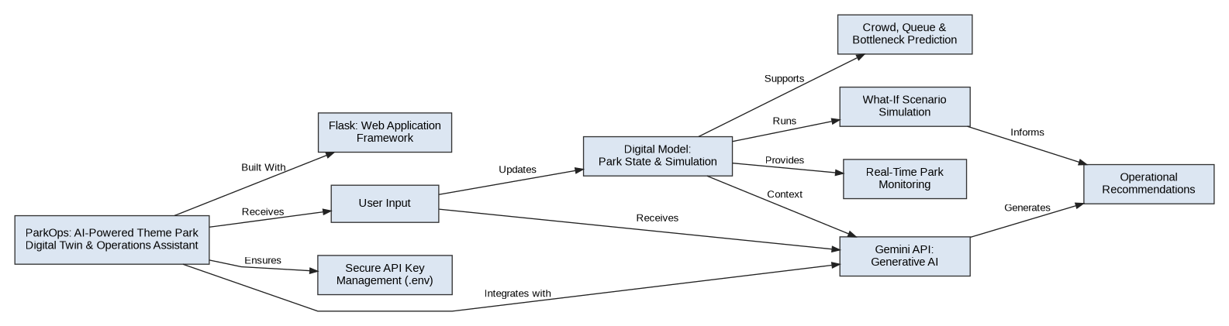
Description:The application follows a four-layer flow. The physical layer supplies the real park state, either from the seeded demo dataset or from an operator-uploaded Excel, CSV or JSON file. The Flask application layer serves the workflow pages and REST APIs and maintains the Digital Model Engine, which holds a virtual copy of the park that can be altered during a simulation without touching the real record. The intelligence layer runs the ParkOps agent across its five capabilities, calling Gemini Flash where a key is configured and falling back to the local engine otherwise. The data and operator layer persists everything in SQLite and closes the loop by returning the human decision to the model.

ER Diagram:
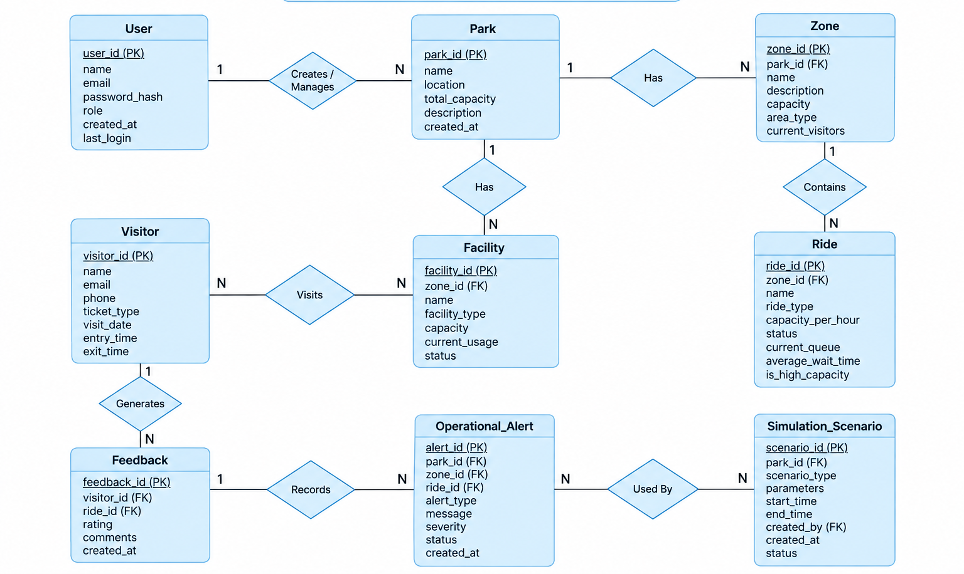

Description:The ParkTwin ER Diagram represents the database structure of the Smart Theme Park Digital Twin system. The User entity stores user details such as name, email, password, and role, while the Park entity stores the main park information and capacity. Each park contains multiple Zones, and each zone contains multiple Rides and Facilities.

Pre-requisites:
Flask Framework Knowledge: Flask Documentation
Google Gemini API Familiarity: Gemini API Documentation
HTML, CSS, and JavaScript Skills: W3Schools HTML/CSS/JavaScript Tutorials
Python Programming Proficiency: Python Documentation
SQLite and SQL Basics: SQLite Documentation
Excel Data Handling with openpyxl: openpyxl Documentation
Chart Rendering in the Browser: Chart.js Documentation
Version Control with Git: Git Documentation
Development Environment Setup: Flask Installation Guide

Project Workflow:

Activity 1: Model Selection and Architecture
- Activity 1.1: Generate a Google Gemini API key and configure it securely in the project environment alongside the Flask session secret.
- Activity 1.2: Research and select the appropriate generative AI model for low-latency theme park operations reasoning.
- Activity 1.3: Define the architecture of the application, detailing interactions between the frontend, the Flask backend, the Digital Model Engine, the agent and the SQLite database.
- Activity 1.4: Set up the development environment, installing the libraries and dependencies required for Flask, the Gemini SDK and Excel parsing.

Activity 2: Core Functionalities Development
- Activity 2.1: Design the operational data schema covering users, parks, zones, rides, facilities, visitors, simulations, recommendations and operator decisions.
- Activity 2.2: Build the Digital Model Engine that maintains the virtual park state and runs sandbox simulations without altering the real record.
- Activity 2.3: Develop the single central ParkOps agent with its five capabilities — monitor, predict, simulate, recommend and analyze.

Activity 3: App.py Development
- Activity 3.1: Write the main application logic in app.py, establishing the nine workflow page routes, authentication and the REST API endpoints.
- Activity 3.2: Integrate the Gemini responses into the recommend and analyze capabilities, with a local fallback path for every call.
- Activity 3.3: Persist simulations and operator decisions to SQLite and expose the dataset import, template download and CSV export endpoints.

Activity 4: Frontend Development
- Activity 4.1: Design and develop the operator interface using HTML, CSS and JavaScript, with a shared dashboard shell and the nine-stage workflow header.
- Activity 4.2: Create dynamic content rendering with the Fetch API so KPI cards, charts and simulation results update without a page reload.

Activity 5: Deployment
- Activity 5.1: Prepare the application for local deployment by configuring the environment and initialising the database schema.
- Activity 5.2: Test and verify each of the nine workflow stages locally before sharing the build.
- Activity 5.3: Deploy the application publicly using Ngrok to expose the local Flask server over a secure public URL.

Activity 6: Conclusion

Milestone 1: Model Selection and Architecture
In this milestone the focus is on selecting the generative AI model that powers the ParkOps agent and on defining how the application is structured around it. Because the agent must answer operator questions against live park data within the span of a single page interaction, model selection is evaluated on latency and instruction adherence rather than on raw capability alone. The milestone also establishes the resilience strategy: every AI call is wrapped so that a missing key, a quota error or a network failure silently drops to the local intelligence engine instead of breaking the operator workflow.

Activity 1.1: Generate a Google Gemini API Key
Before the application can communicate with Gemini, you need a valid API key. Follow the steps below to create one and connect it securely to the project.
- Step 1 — Open Google AI Studio: Visit https://aistudio.google.com and sign in with your Google account.
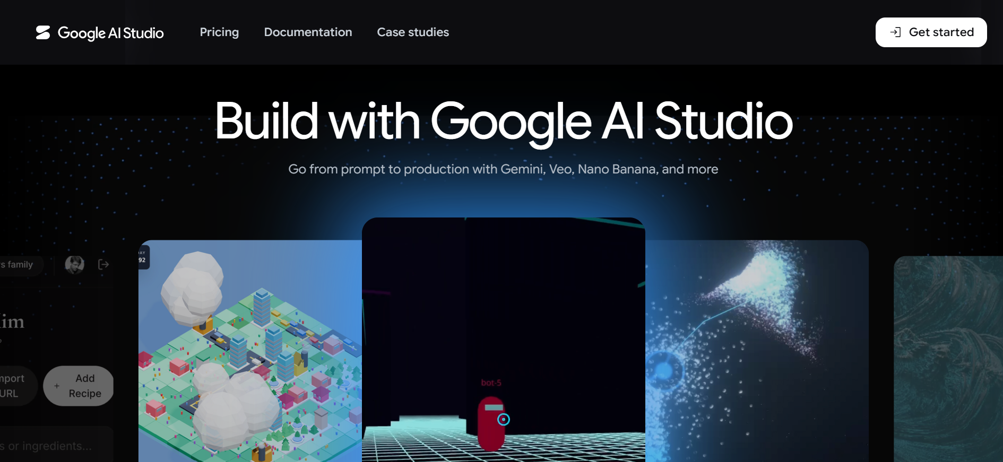
- Step 2 — Create an API Key: Click “Get API key”, then “Create API key”, and select or create a Google Cloud project to associate it with.
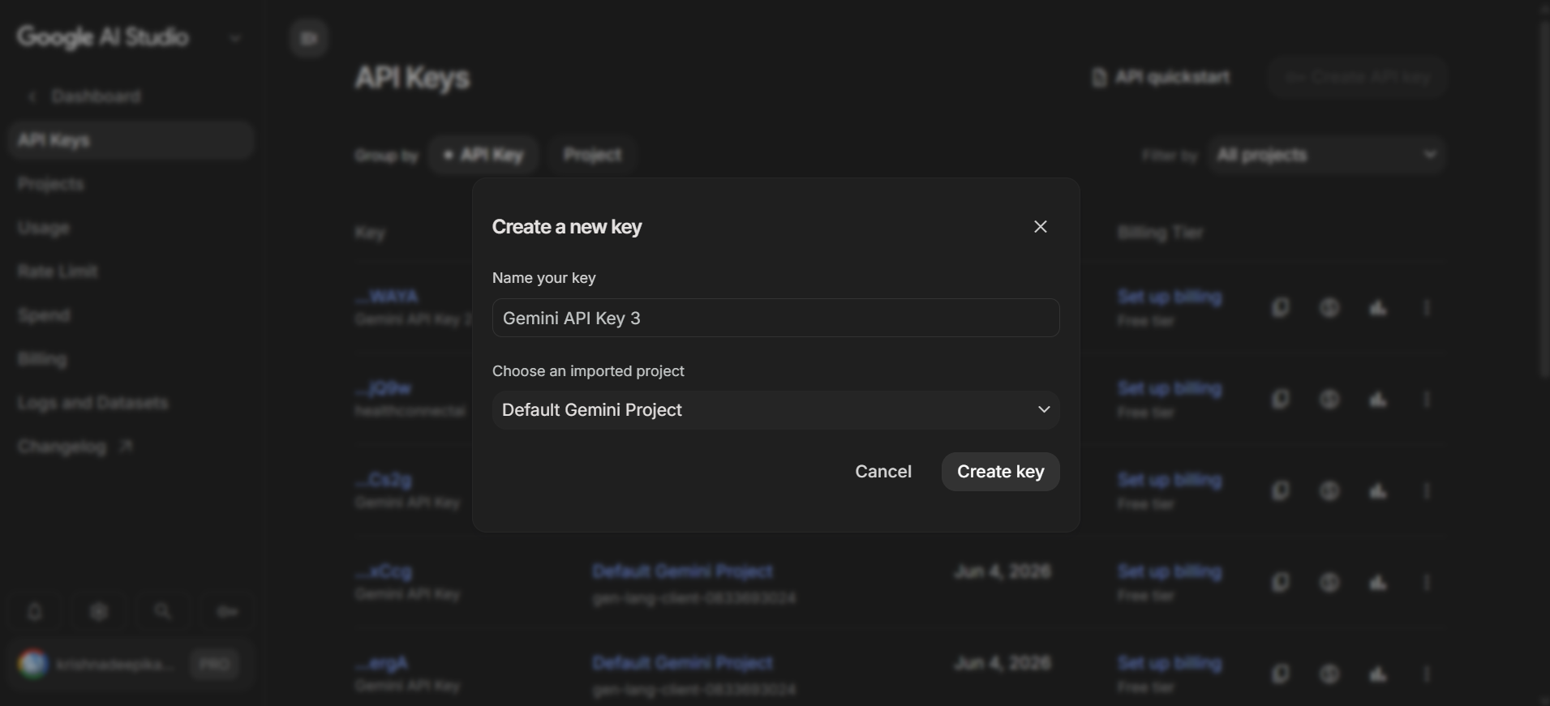
- Step 3 — Copy the Key: Copy the generated key immediately and store it somewhere safe — it will not be shown in full again.
- Step 4 — Add the Key to Your Project: Create a .env file in the project root and add the key along with the other secrets the app needs:
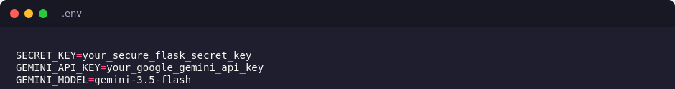
- Step 5 — Load the Key at Startup: config.py reads every credential from the environment using python-dotenv, with sensible fallbacks:
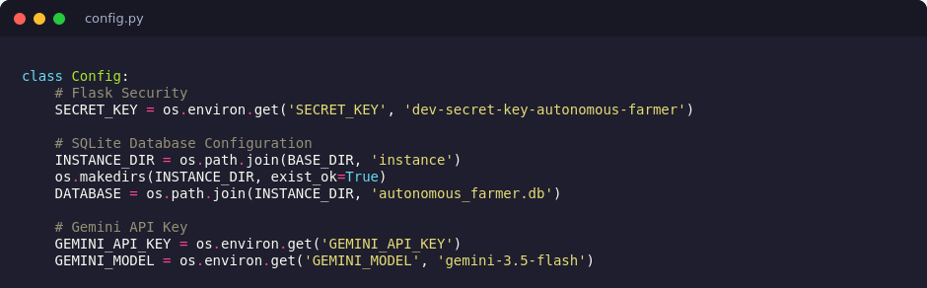
- Important — Never Commit Your API Key: Add .env to .gitignore so the key is never pushed to a public repository.

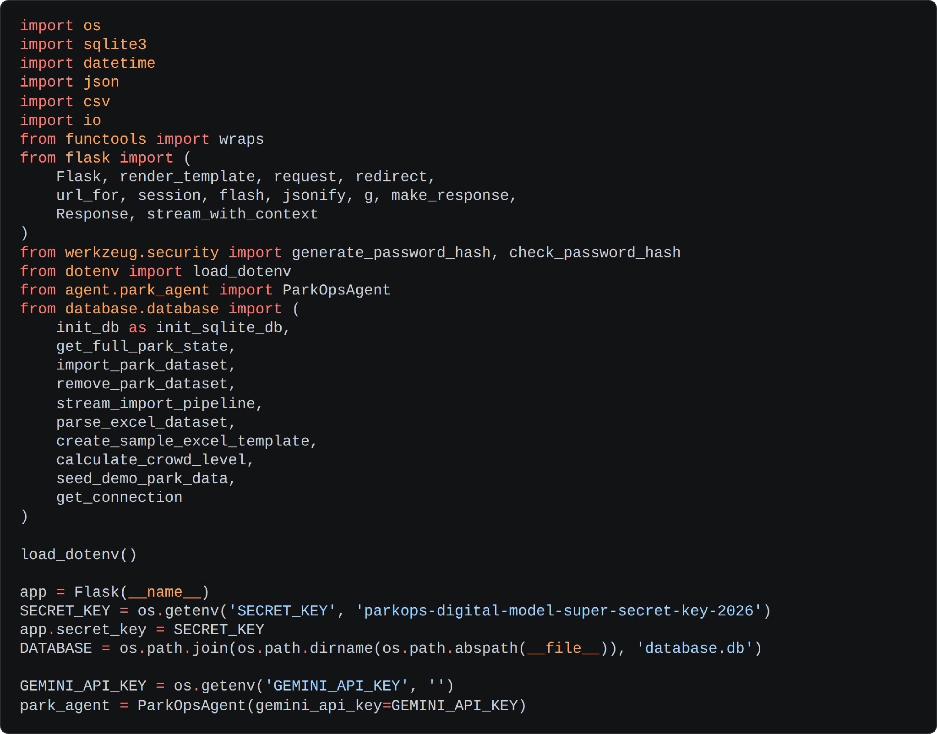
• Step 6 — Understand the Fallback Guard: The agent filters out empty and placeholder keys before deciding whether it is connected, and exposes that state through the model name and status label shown in the interface:
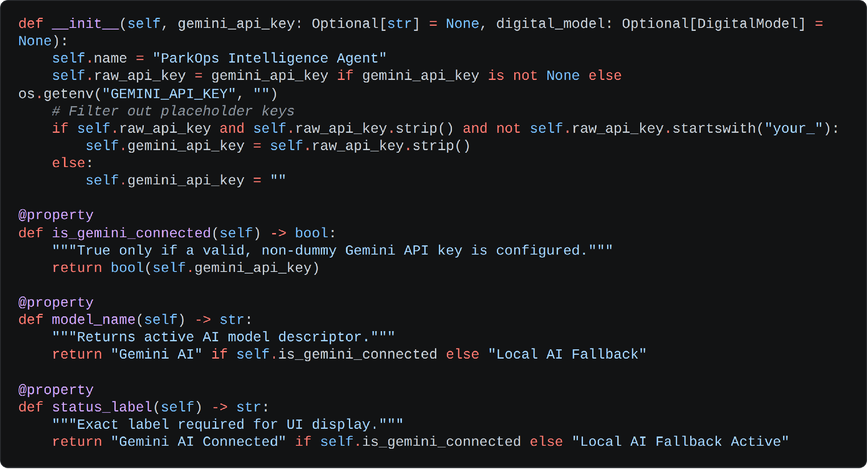
• Important — Never Commit Your API Key: The project already ships a .gitignore; confirm that it excludes the environment file and the local database so neither is pushed to a public repository:
.env
database.db

Activity 1.2: Research and Select the Appropriate Generative AI Model
- Understand the Project Requirements: Review what ParkOps must generate — short, actionable operator recommendations and direct answers to natural-language questions grounded in the live dataset, both delivered fast enough to feel interactive.
- Explore the Gemini Model Documentation: Examine the available Gemini models, comparing context window, instruction-following behaviour, response latency and free-tier quota.
- Evaluate Model Performance: Compare candidates on how tightly they honour a short-answer constraint, how reliably they stay on the operations domain rather than drifting into generic advice, and how consistently they reflect the injected state values.
- Select the Optimal Model: Choose gemini-1.5-flash for its balance of reasoning quality and speed, which suits an operations console where the operator is waiting on screen for an answer.
- Define the Offline Guarantee: Retain a deterministic local intelligence engine inside the agent so that a recommendation is still produced when no key is configured or a call fails, keeping the nine-stage workflow usable in every environment.

Activity 1.3: Define the Architecture of the Application
- Draft an Architectural Diagram: Create a visual representation of the application covering the physical park and its dataset, the Flask backend, the Digital Model Engine, the ParkOps agent, the Gemini integration and the SQLite database.
- Detail Frontend Functionality: Outline how operators move through the nine workflow stages, entering simulation parameters, reading KPI cards and charts, and acting on the recommendation presented to them.
- Outline Backend Responsibilities: Specify how the Flask backend serves each stage page, protects them with a login_required decorator, validates incoming JSON on the simulation and decision endpoints, and writes results to the database.
- Separate the Virtual State from the Real State: Define the rule that makes the digital model safe — a simulation operates on a virtual copy of the park state and caches the result separately, so the physical record is never mutated by a what-if test.
- Describe AI Integration Points: Define the two places where Gemini is called — recommend(), which turns a simulation result into an operator instruction, and analyze(), which answers an operator question against the injected live state — each guarded by a try block that falls through to the local engine.
- Close the Feedback Loop: Specify how an applied operator decision feeds back into the digital model as an active mitigation, so the next monitoring cycle reflects the action that was taken.

Activity 1.4: Set Up the Development Environment
- Install Python and Pip: Ensure Python 3.8 or later is installed on your machine along with pip for dependency management.
- Create a Virtual Environment: Set up a virtual environment using venv to isolate project dependencies:
python -m venv parkops-env
parkops-env\Scripts\activate # For Windows
source parkops-env/bin/activate # For macOS/Linux
- Install the Dependencies: The project depends on Flask and Werkzeug for the web layer, python-dotenv for configuration, the Gemini SDK for the agent, and openpyxl for the Excel import and template pipeline:
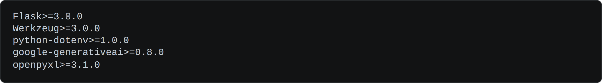
pip install -r requirements.txt
- Configure the Environment File: Create the .env file in the project root and add the Gemini key and the Flask secret prepared in Activity 1.1.
- Set Up the Application Structure: Create the project directory structure — the agent package holding park_agent.py, the simulation package holding digital_model.py, the database package holding database.py, the templates folder for the workflow pages, the static folder for CSS, JavaScript and imagery, and app.py at the root.
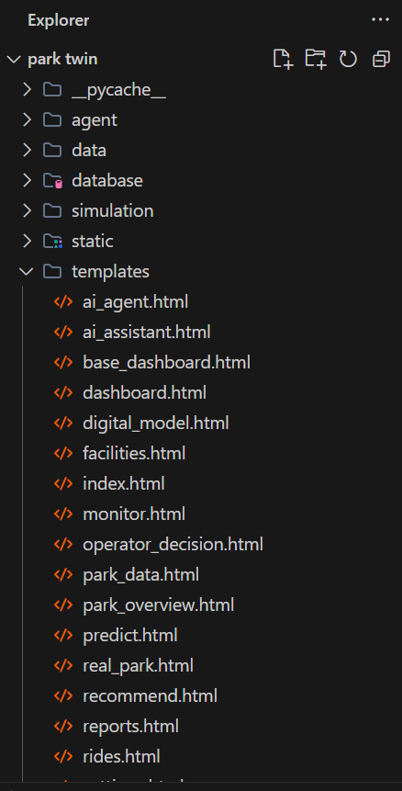

Milestone 2: Core Functionalities Development
Milestone 2 establishes the domain model beneath every page of the application: the SQLite schema that holds the park and its operational history, the Digital Model Engine that maintains the virtual replica, and the single central agent that reasons over both.

Activity 2.1: Design the Operational Data Schema
All persistence is handled by a single SQLite database, initialised by init_db() without any automatic demo seeding — the operator decides whether to load the demo park or import their own dataset.
- users: stores the operator account with full name, unique email, hashed password, contact details and an operational role.
- parks and zones: hold the park record and its sectors, each zone carrying a capacity and a live visitor count from which occupancy is derived.
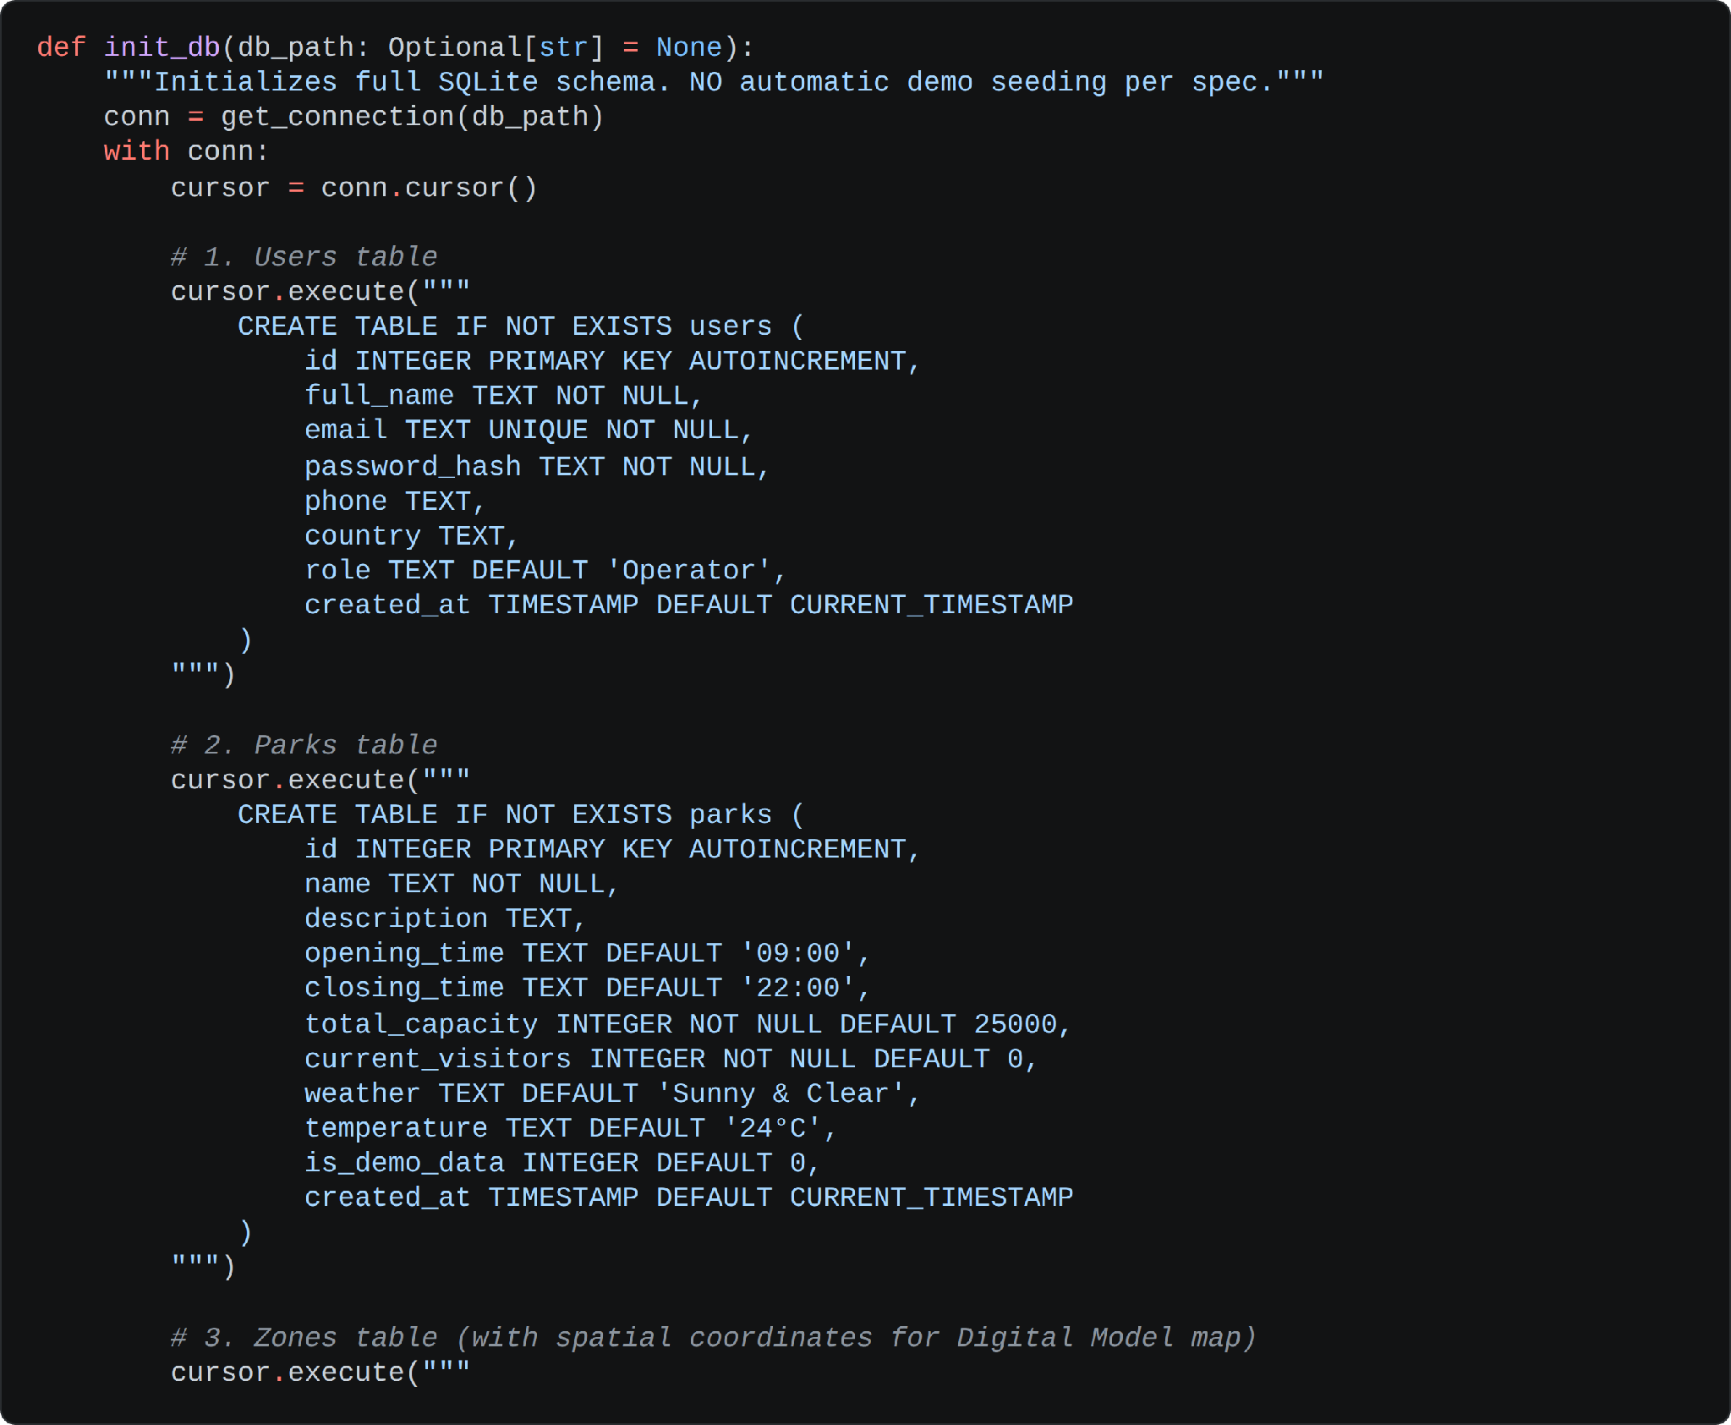
- rides, facilities and visitors: capture the ride fleet with status and queue length, the support facilities with demand against capacity, and the visitor flow records.
- simulation_history: records every what-if run with its parameters, predicted visitors, predicted queue time, crowd density, bottleneck zone and the recommendation that was produced.
- ai_activity: stores the concise operational event timeline surfaced on the AI Agent page.
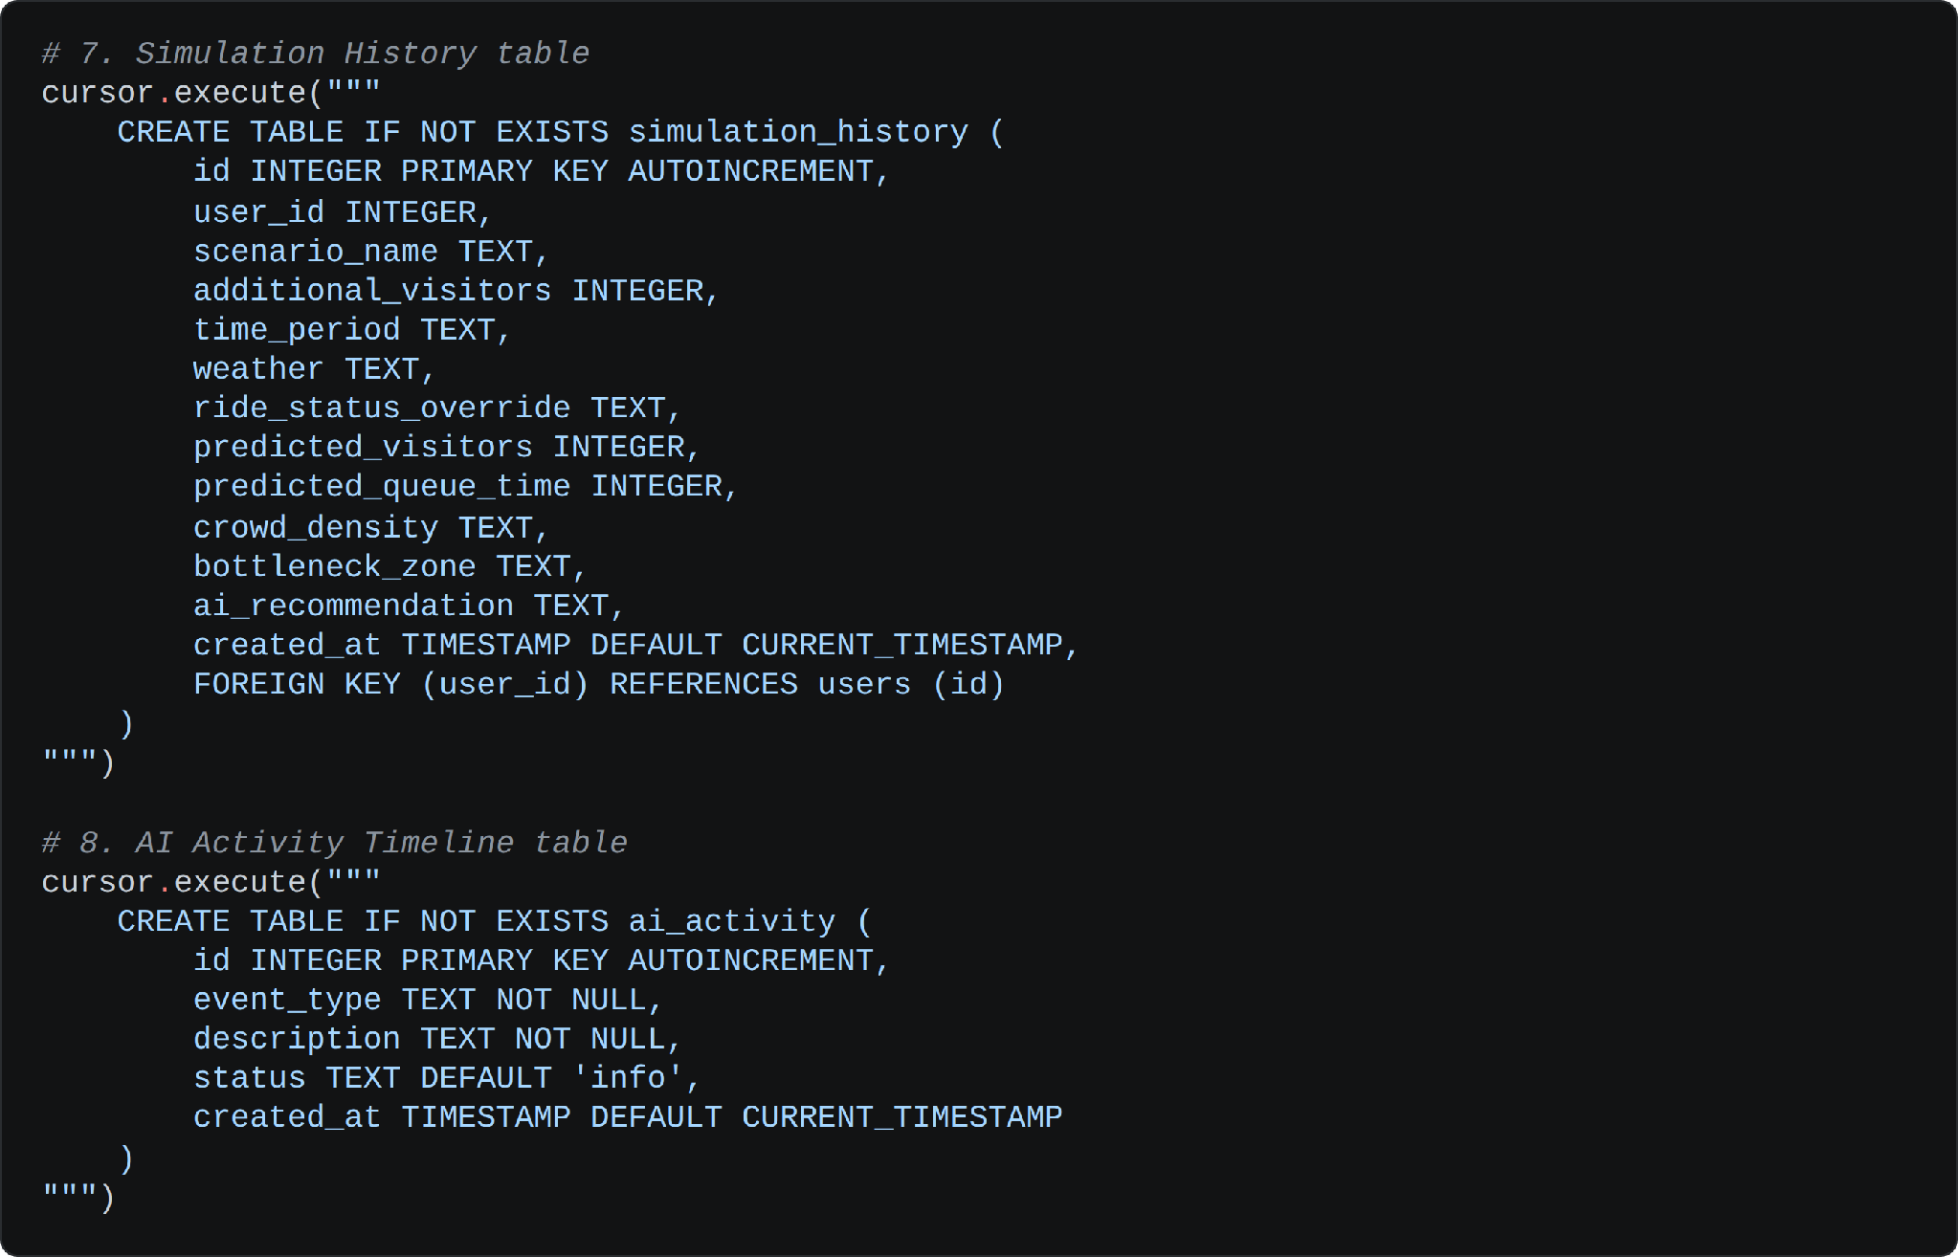
- ai_recommendations and operator_decisions: persist each generated recommendation with its risk level and confidence score, and each human decision with the action taken, so the full chain from simulation to operator action is auditable.
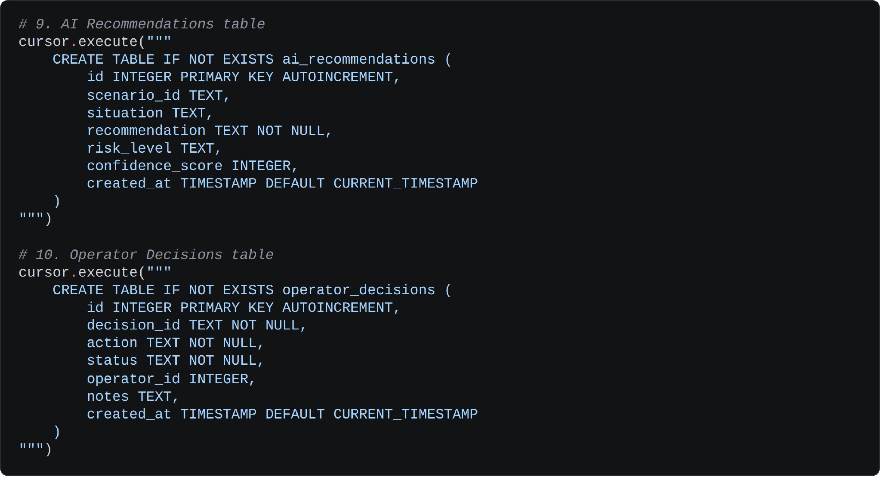
- Derived Crowd Levels: crowd density is never stored as a free-text guess — it is computed from the current visitor count against capacity, returning a label, a percentage and a display colour used consistently across every page.
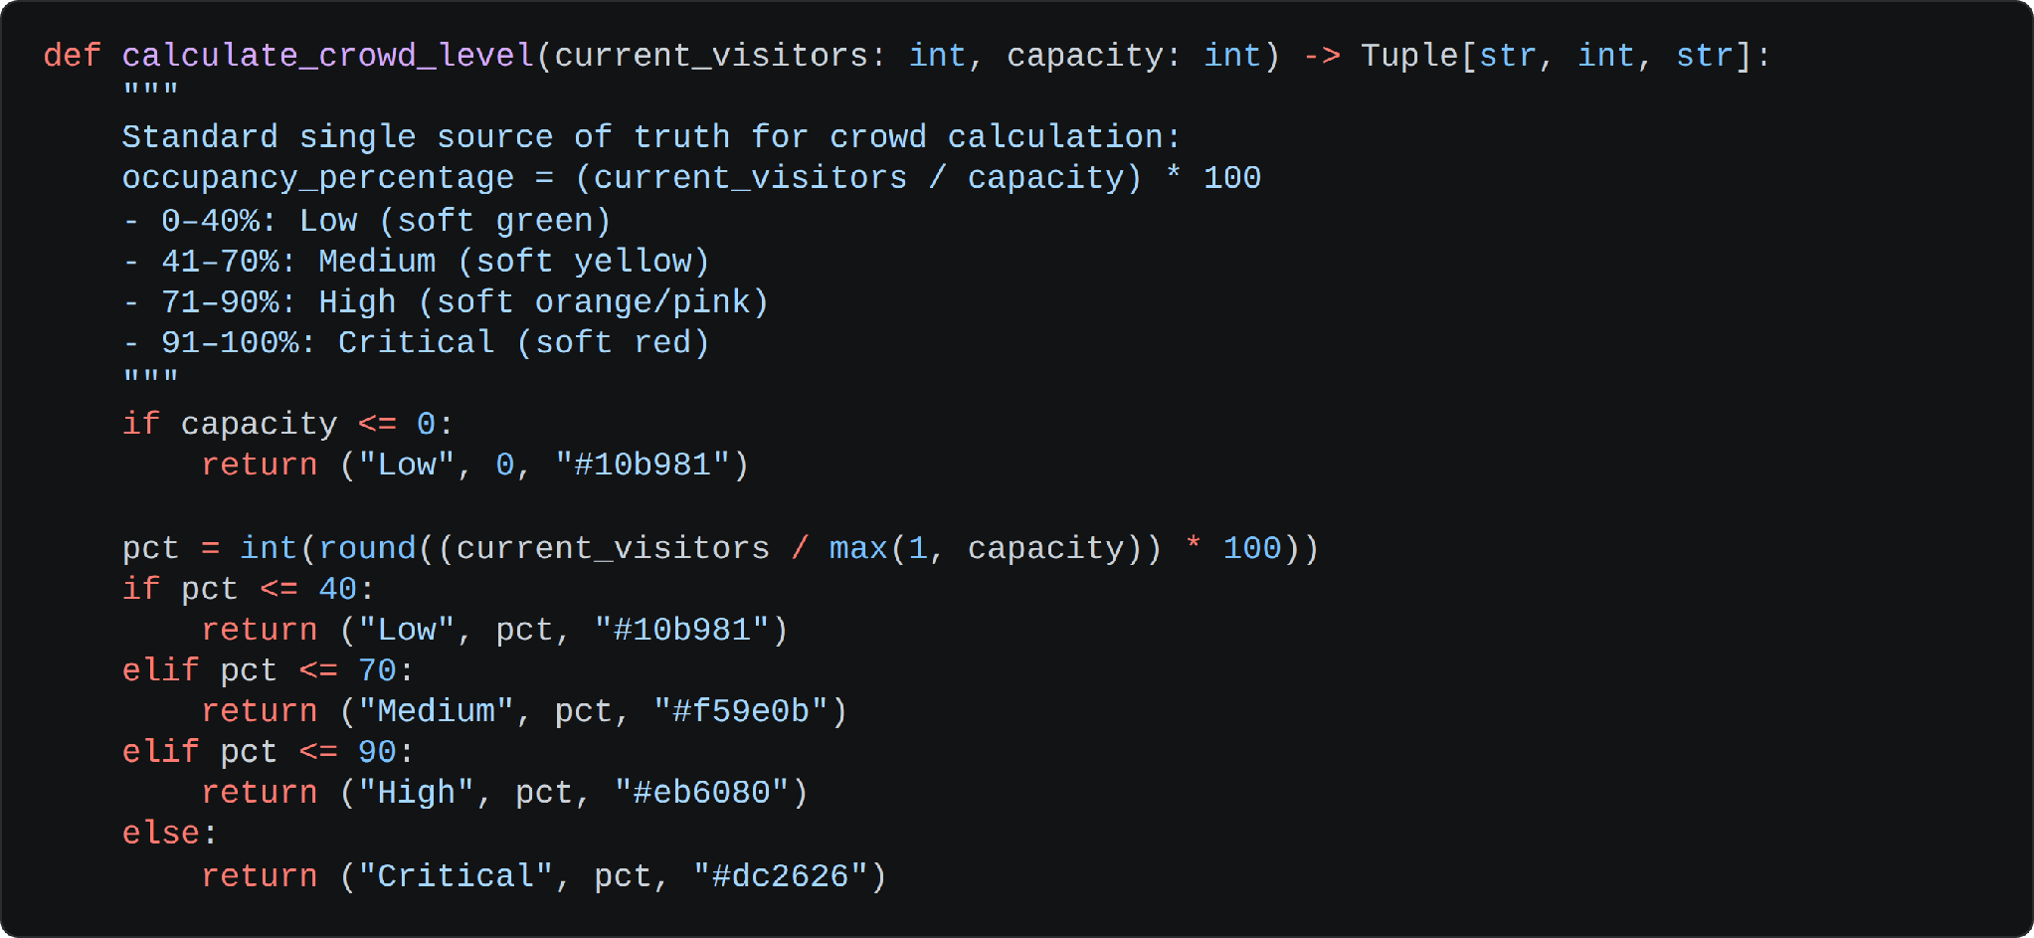

Activity 2.2: Build the Digital Model Engine
The Digital Model Engine is the virtual representation of the park. It synchronises the physical telemetry into a structured state, keeps a separate simulated state for what-if testing, and calculates queue impacts, zone densities and facility demand on demand.
- Baseline Park Metadata: the engine carries the park name, total capacity, day type, scheduled special events, weather and current time as the context every calculation starts from.
- Structured Current State: visitors, rides, facilities, zones, averages and the operational plan are held in one dictionary, so a single call returns everything a page needs.
- Isolated Simulated State: a separate simulated_state cache holds the virtual result of a what-if run, which is why a simulation never alters the real database.
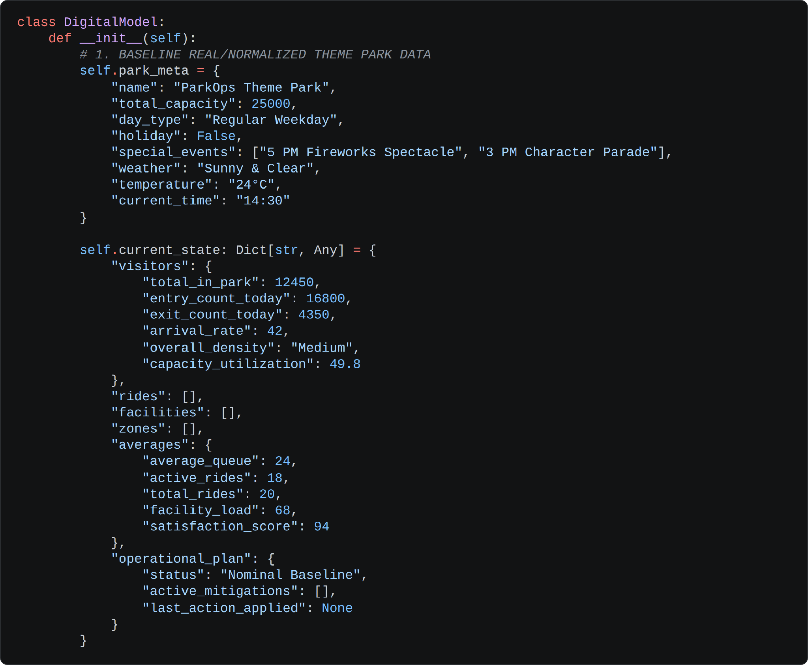

Activity 2.3: Define the Single Central Agent
Rather than spreading logic across several specialised agents, ParkOps uses one central intelligence agent that exposes five capabilities over the same digital model. This keeps the operational state consistent — every capability reasons over the identical park snapshot.
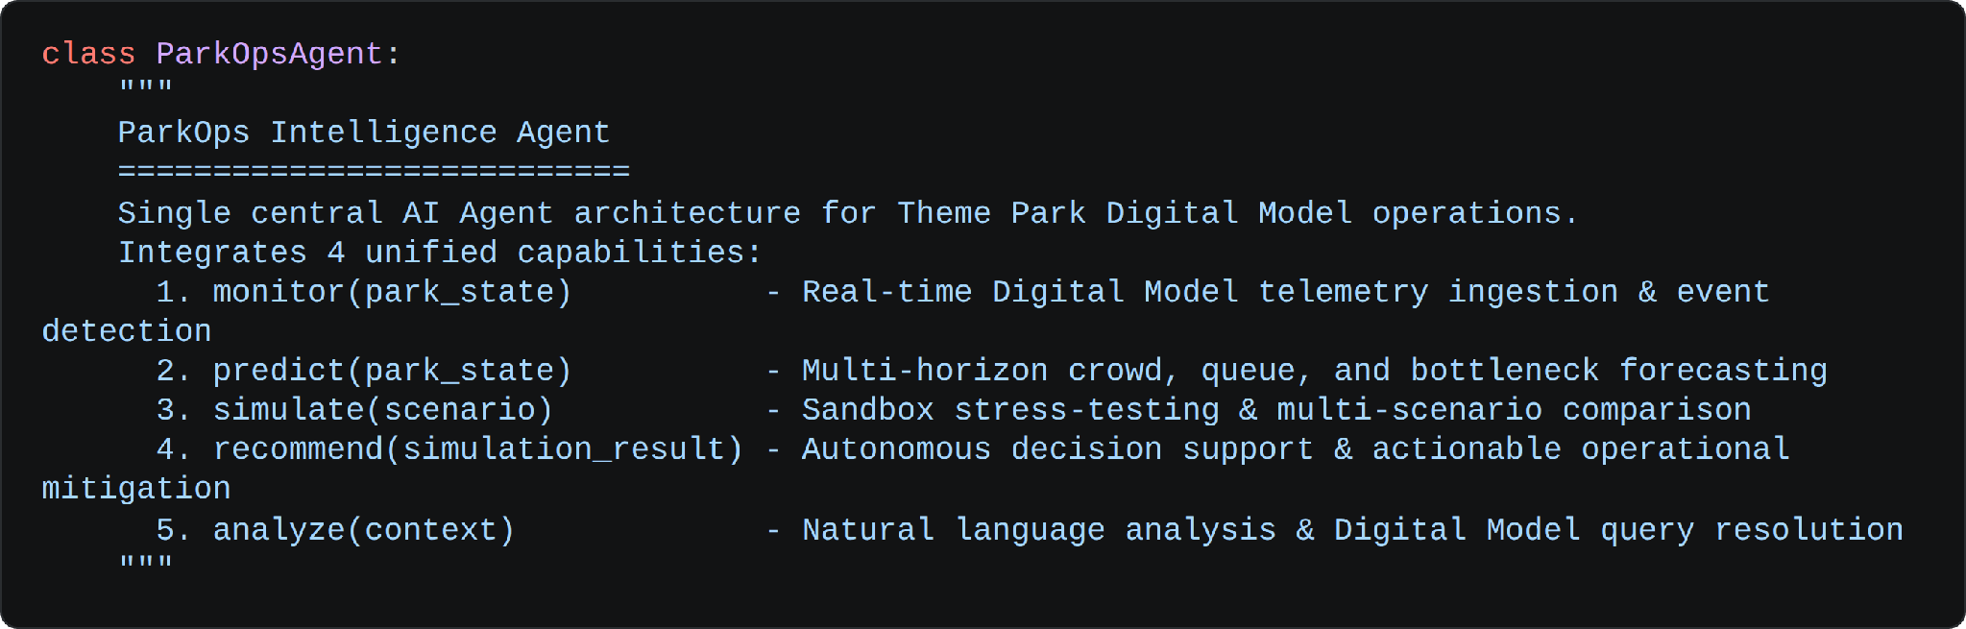
- Operational Activity Log: the agent keeps a rolling timeline of concise operational events — data received, crowd density analyzed, bottleneck detected, recommendation generated — capped at twenty entries and never exposing internal reasoning.
- Connection State: the agent reports itself as either “Gemini AI Connected” or “Local AI Fallback Active”, and the interface reflects that label so the operator always knows which engine produced an answer.
- Latest Decision Record: the current decision — situation, impact, prediction, risk, confidence and recommendation — is held on the agent and awaits an explicit operator action.

Milestone 3: App.py Development
Milestone 3 focuses on creating and refining the core logic of app.py, which serves as the backbone of ParkOps. In this milestone you set up each workflow stage through Flask routes, establish reliable agent interaction, and verify that every endpoint behaves correctly under both success and failure conditions.

Activity 3.1: Writing the Main Application Logic in app.py
Define the Core Page Routes in app.py:
- / , /signin , /signup , /logout — the public landing page and the authentication flow.
- /dashboard — the operations overview with KPI cards, charts and the agent monitoring panel.
- /real-park and /park-data — workflow stages one and two: the physical park state and the dataset upload and import pipeline.
- /digital-model and /ai-agent — stages three and four: the virtual park and the agent with its activity timeline.
- /monitor , /predict , /simulate — stages five, six and seven: live monitoring, forward forecasting and what-if scenario testing.
- /recommend and /operator-decision — stages eight and nine: the agent recommendation and the human decision that closes the loop.
- /park-overview , /rides , /visitors , /facilities — the dataset explorer views over the imported park record.
- /ai-assistant , /reports , /settings — the natural-language assistant, the simulation history with CSV export, and account preferences.
Protect Every Operational Page with a Decorator:
- A login_required decorator wraps each private route, flashing a prompt and redirecting anonymous visitors to the sign-in page with the original destination preserved in the next parameter.
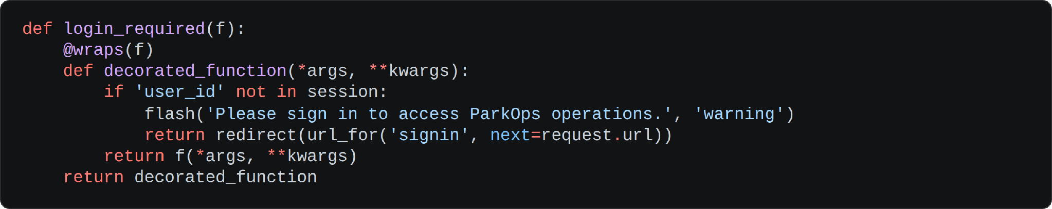
Implement Secure Authentication:
- Validate the Submitted Fields: the signup handler checks that all required fields are present, that the password is at least six characters, that both password entries match, and that the email is structurally valid.
- Prevent Duplicate Accounts: an existing email is rejected with a clear message rather than creating a second record.
- Hash Before Storage: generate_password_hash() from Werkzeug hashes the password before insert, and check_password_hash() verifies it on sign-in, so credentials are never stored in plaintext.
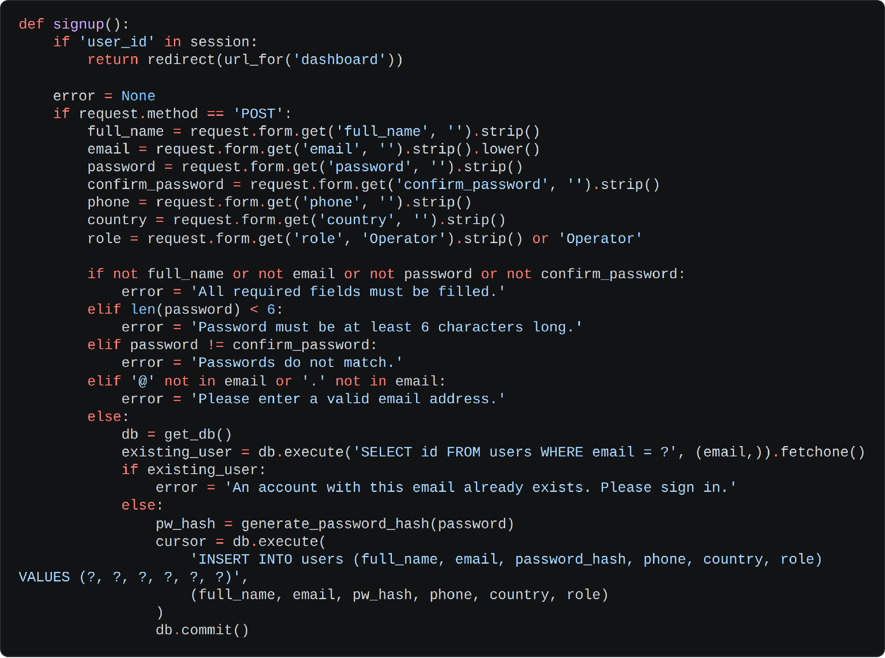
Serve the Dashboard from Live State:
- The dashboard route pulls the full park state from SQLite, passes the averages, zones, rides and facilities into the template, and calls the agent’s monitor() capability so the page renders the current telemetry snapshot in a single request.
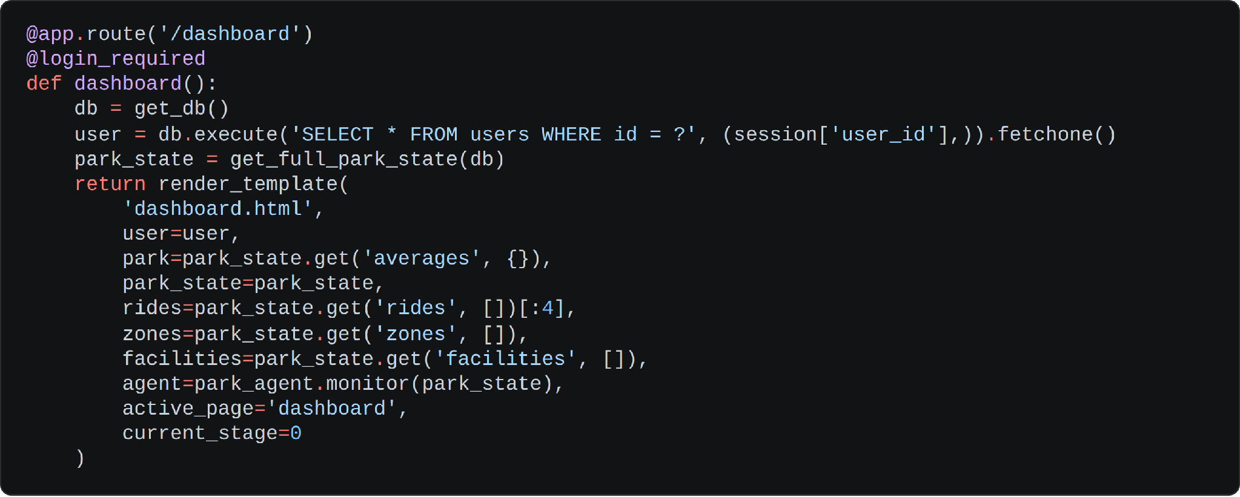
- A companion JSON endpoint feeds the browser charts — KPI values, the visitor flow actual-versus-predicted series, the queue trend, crowd by zone and ride utilisation — all derived from the same park state.
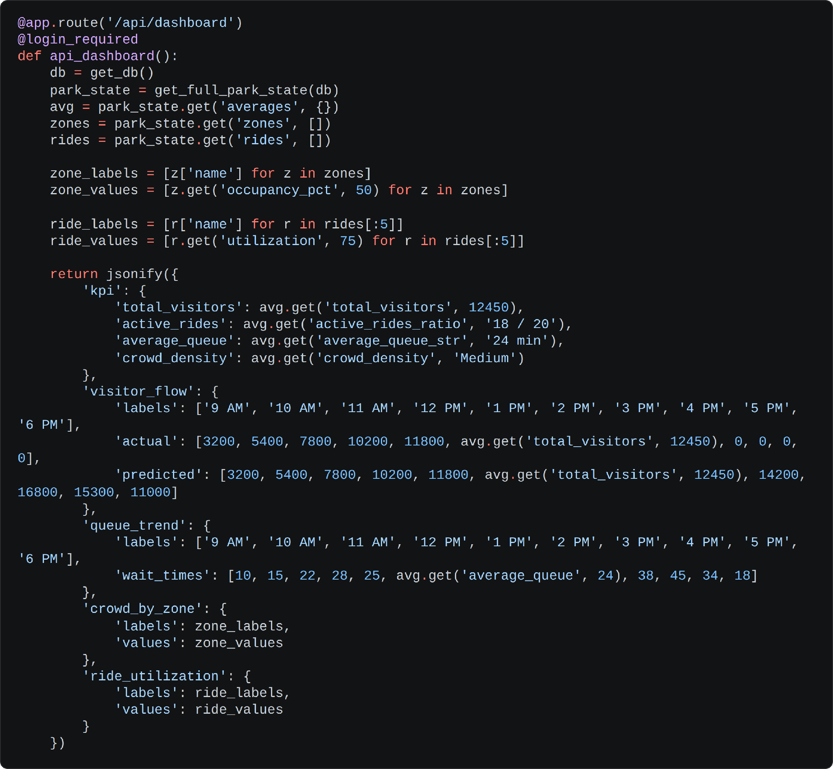
Implement the Five Agent Capabilities:
- 1. Monitor: ingests the current digital model summary, detects operational events, and returns the live state together with the agent mode, confidence score and connection label.
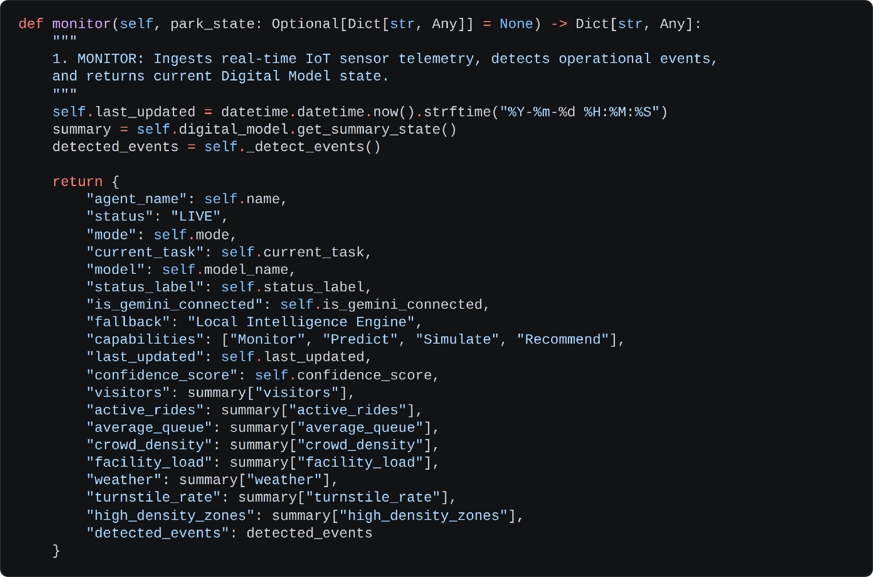
- 2. Predict: projects visitors forward over a two-hour horizon, ranks zones by occupancy to identify the top three bottlenecks, grades each as Moderate, High or Critical, and estimates the queue impact in minutes.
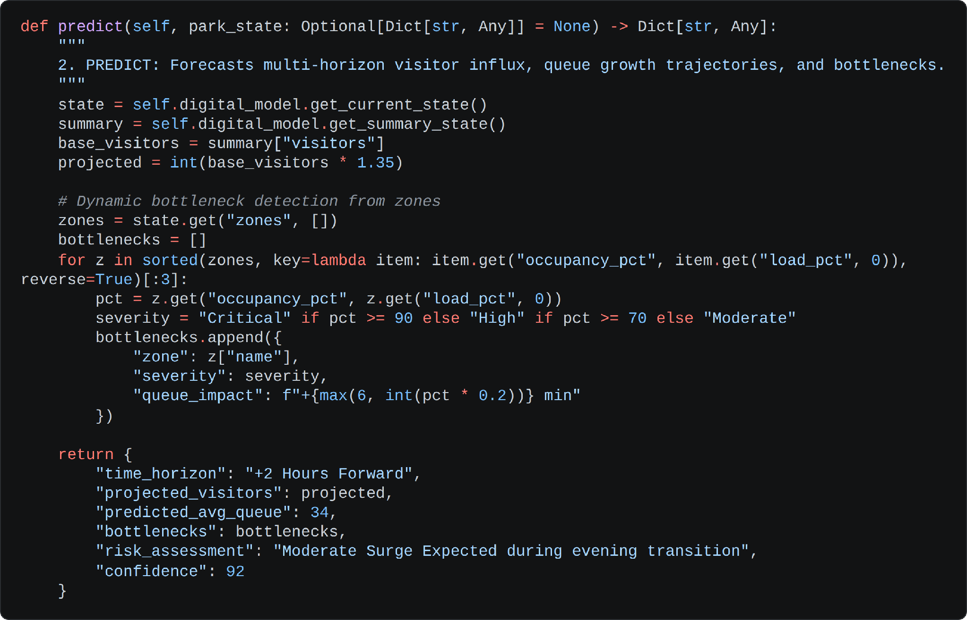
- 3. Simulate — Scenario Input: the what-if run reads the additional visitors, time period, ride availability and weather, then applies multipliers — rain or storm adds twenty-five percent, a ride breakdown adds forty-five percent — on top of the live baseline.
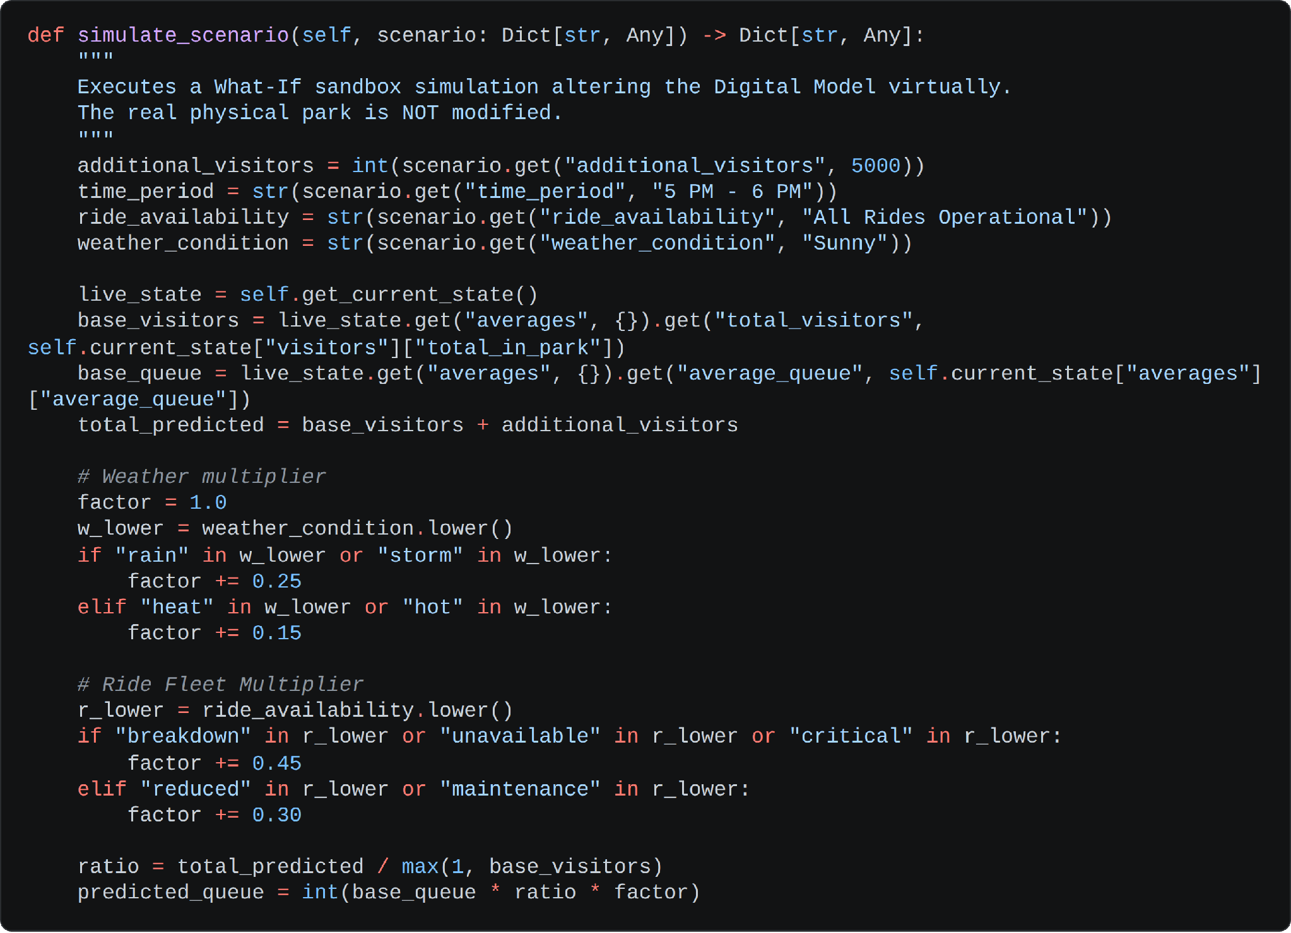
- 3. Simulate — Outcome Classification: the projected headcount is banded into a crowd density, a named bottleneck and a risk level, the facility demand is derived from the same threshold, and the whole result is cached as the simulated state without touching the real record.
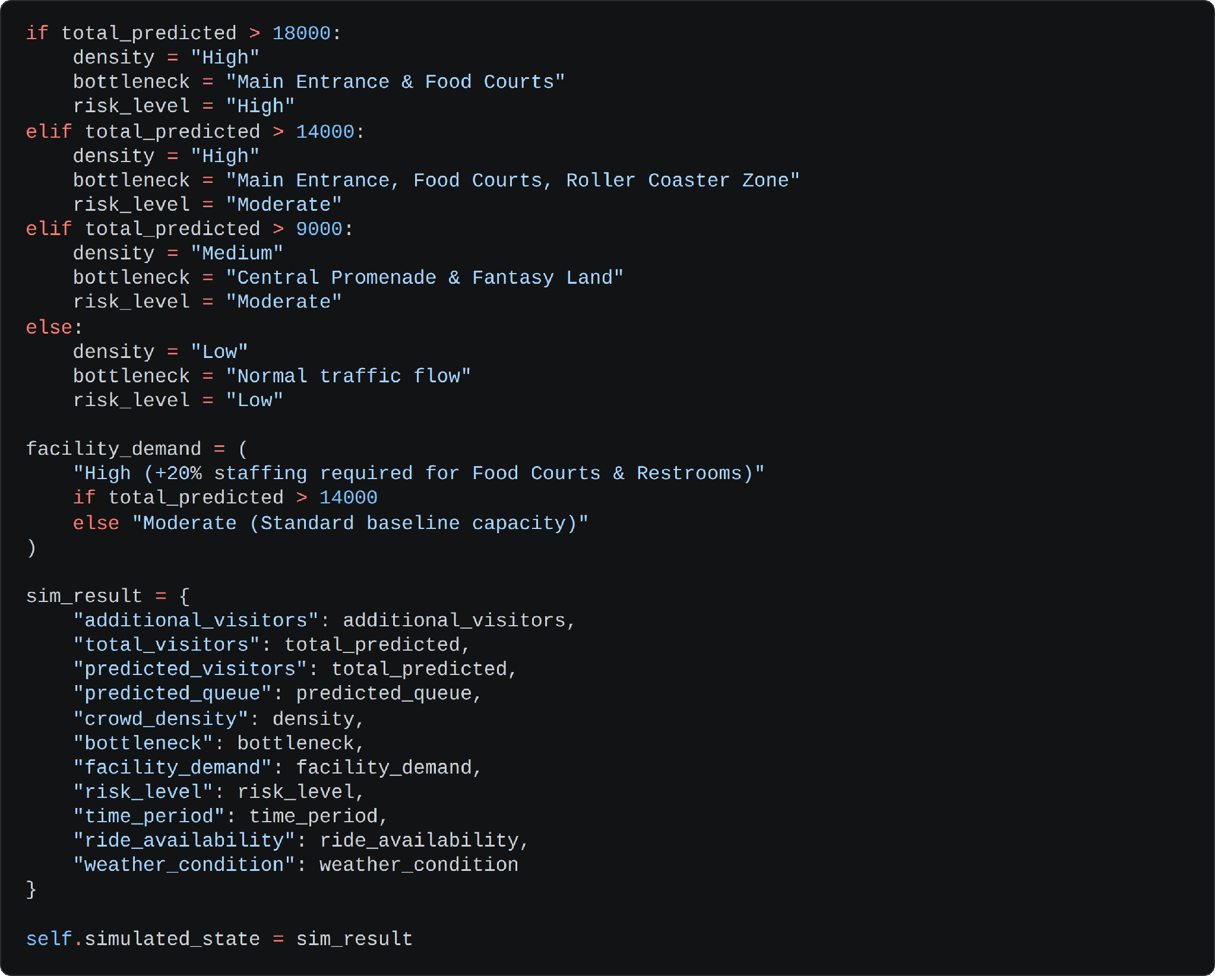
- 4. Recommend — Gemini Path: the simulation result is injected into a compact prompt that asks for a crisp two-sentence operator instruction covering visitor redistribution and facility staffing.
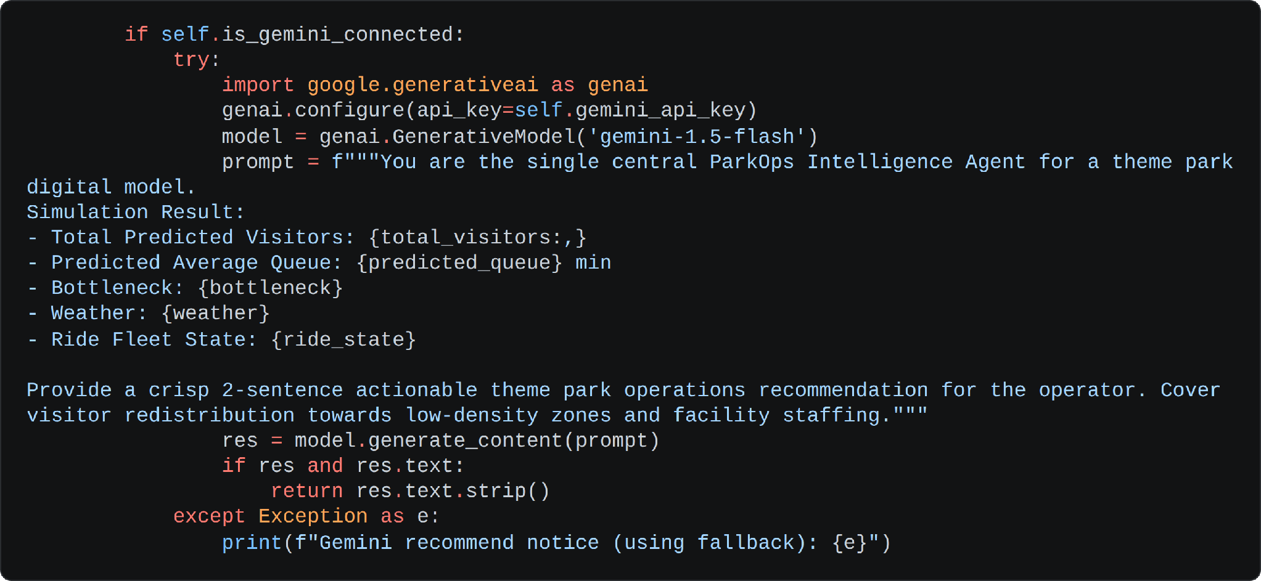
- 4. Recommend — Local Fallback: if the call fails or no key is configured, deterministic rules produce a matching recommendation based on the weather, the ride fleet state and the projected headcount, so the operator is never left without guidance.
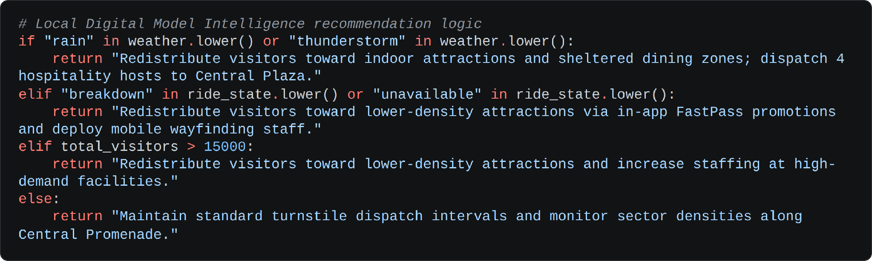
- 5. Analyze — Grounded Question Answering: the live database state is computed first — most and least crowded zone, longest-queue ride, highest-demand facility — and injected into the prompt, with explicit instructions to answer only the question asked, stay dataset-driven, and decline anything outside park operations.
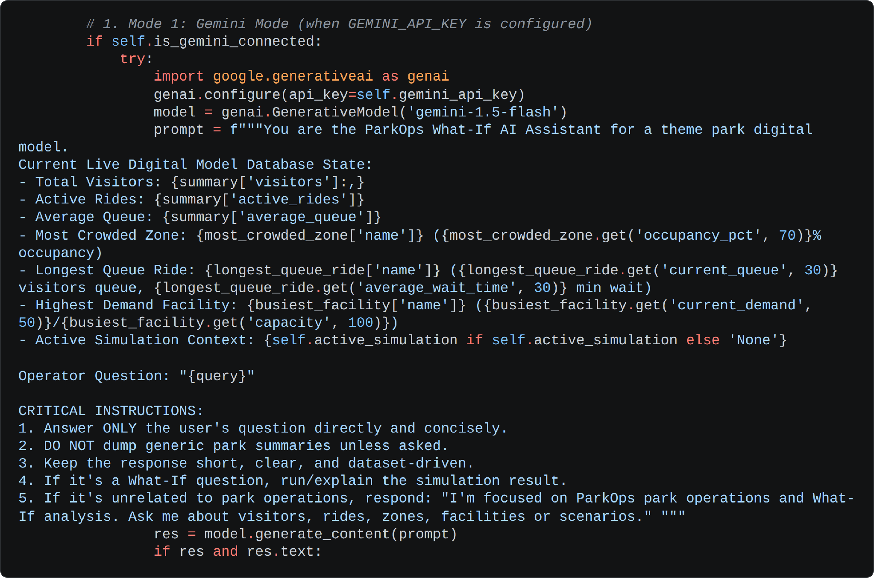
Build the Operational REST APIs:
- /api/simulate — sanitises the scenario parameters, runs the agent simulation and writes the full run to simulation_history so it appears in the reports view.
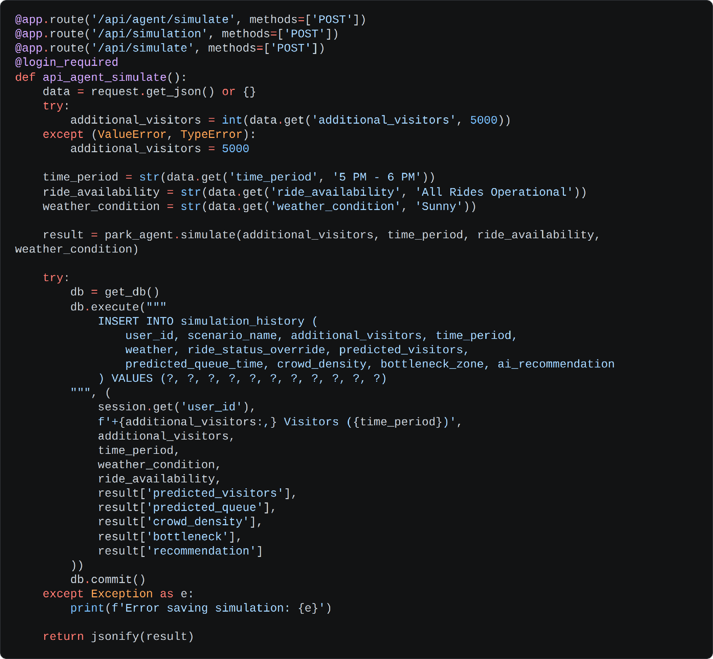
- /api/agent/apply-decision: Routes operator choices—such as applying, saving, or rejecting recommendations—directly to the underlying agent.
It strictly validates incoming request JSON payloads to ensure all mandatory parameter fields are present and properly formatted.
The endpoint persists the complete decision record to SQLite while instantly updating the virtual digital model state.
This creates a traceable audit trail for compliance and returns an updated operational status snapshot back to the frontend.
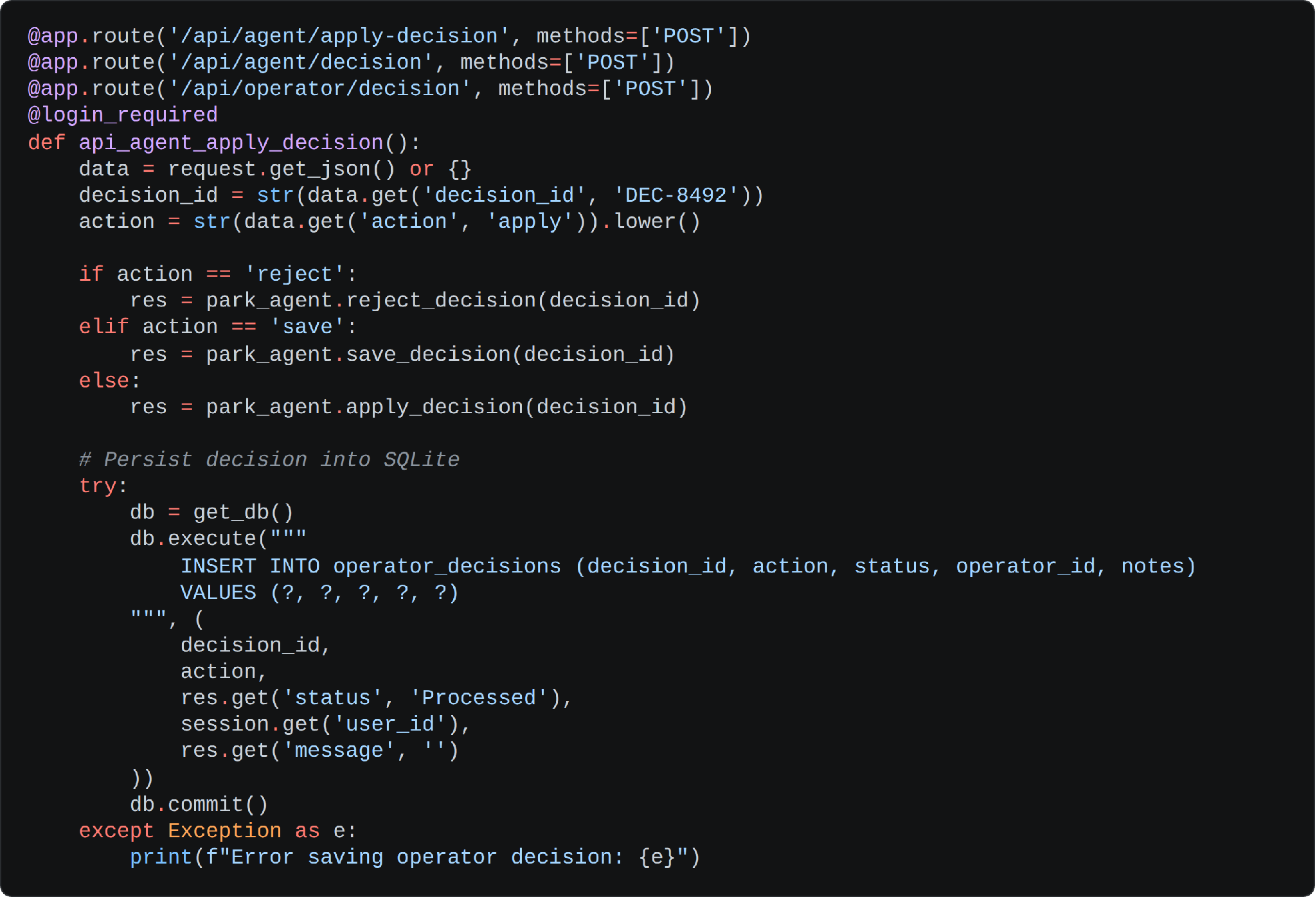
- /api/park-data/import — accepts an Excel, CSV or JSON upload, dispatches to the matching parser and writes the dataset into the park tables, replacing the previous record.
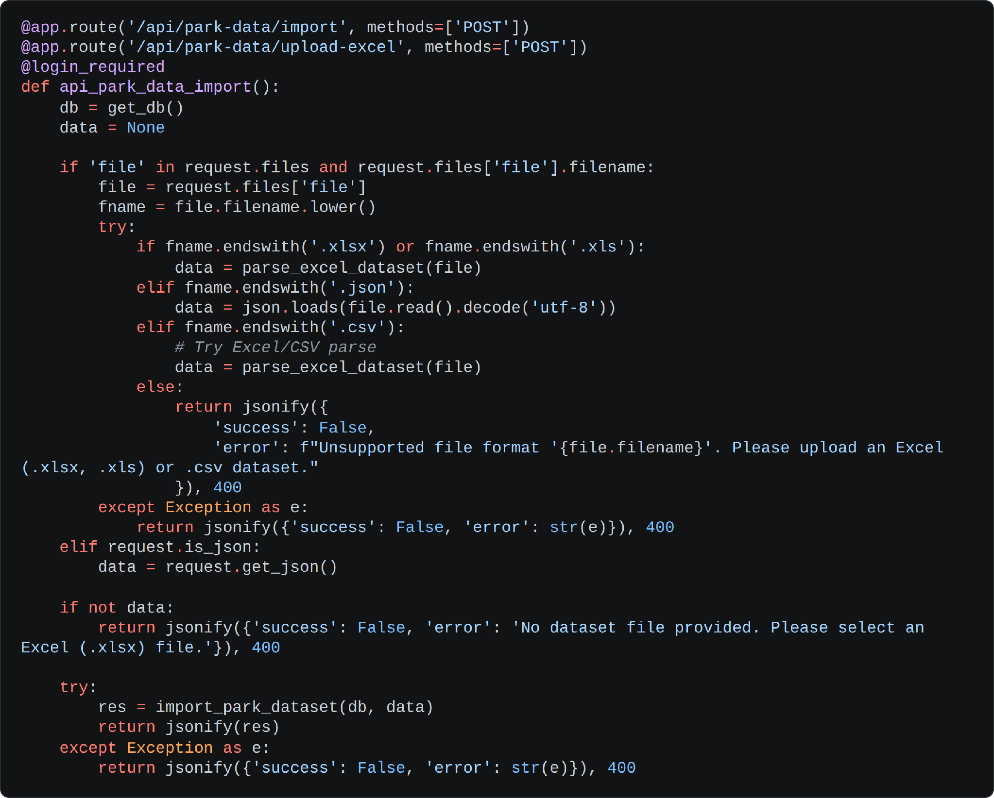
- /api/export-report — streams the full simulation history back as a downloadable CSV operational report.
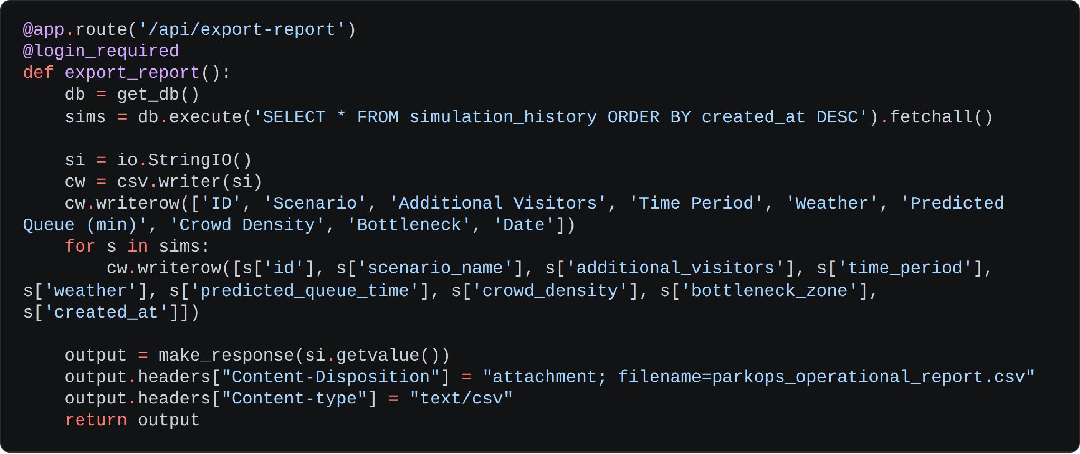
- /api/park-data/template , /api/park-state , /api/rides , /api/facilities , /api/agent/status — serve the generated Excel template, the raw park state and the supporting read endpoints consumed by the dashboard and explorer pages.

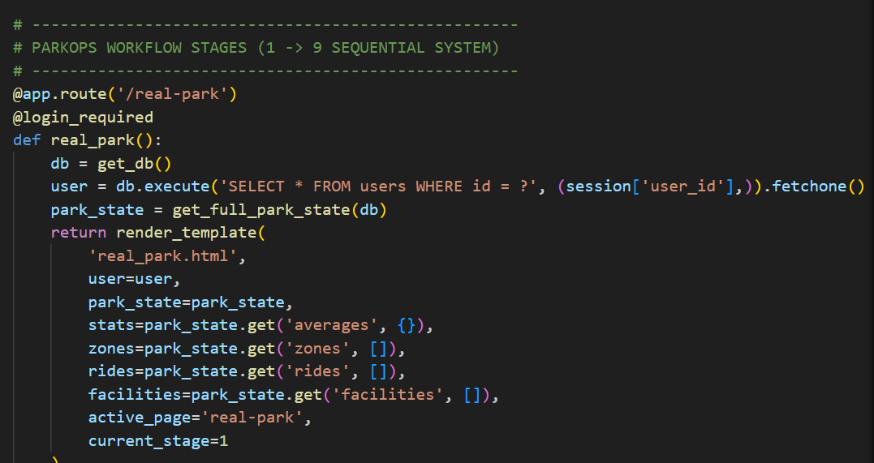
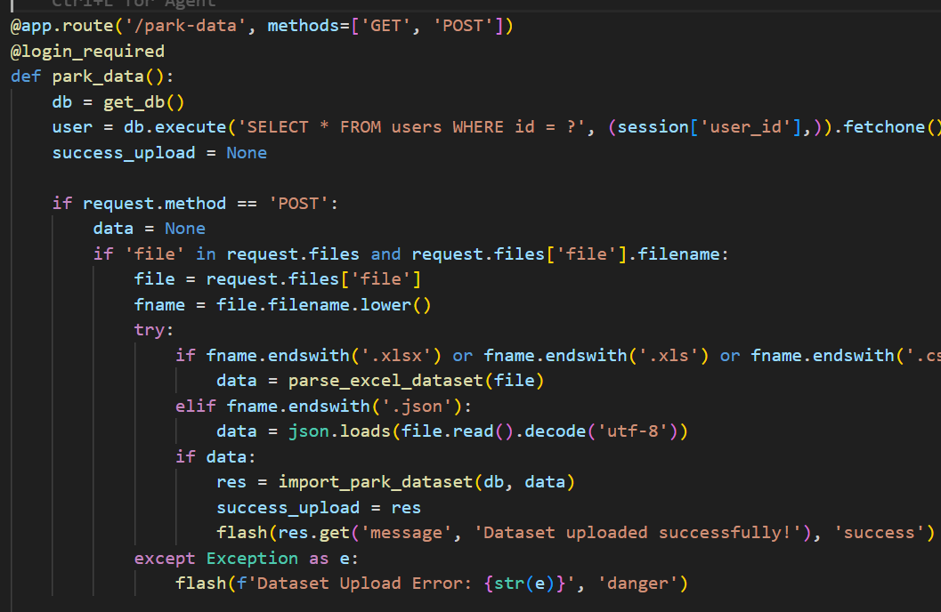
Milestone 4: Frontend Development
Milestone 4 focuses on developing a clear, operations-grade interface for ParkOps. This involves designing a shared dashboard shell with the nine-stage workflow header so the operator always knows where they are in the process, and creating dynamic content rendering with vanilla JavaScript so simulations and charts update in place without a page reload.

Activity 4.1: Designing and Developing the User Interface
Set Up the Base Template Structure:
- Develop base_dashboard.html as the shared shell for every signed-in page, with the sidebar navigation, the header and the flash message region defined once and inherited by each stage template.
- Build workflow_header.html as a reusable nine-stage progress strip — Real Park, Park Data, Digital Model, AI Agent, Monitor, Predict, What-If, Recommend and Operator — with the current stage highlighted through the current_stage value passed by each route.
- Use semantic HTML elements throughout so the interface stays organised and accessible.
Design a Responsive Layout Using CSS:
- Create a single stylesheet at static/css/style.css built on CSS custom properties, so the navy operations palette and the status colours are defined once and reused across every component.
- Use flexbox and grid layouts for the KPI card row, the chart panels and the two-column simulation view.
- Add media queries so the sidebar collapses and the card grids reflow cleanly on tablet and laptop screens.
Create Dedicated UI Components for Each Output Type:
- KPI Cards: total visitors, active rides, average queue and crowd density, each bound to the live park state.
- Chart Panels: visitor flow with an actual-versus-predicted overlay, queue trend, crowd by zone and ride utilisation, all fed by the dashboard JSON endpoint.
- Scenario Form: additional visitors, time period, ride availability and weather condition, submitted as a single what-if payload.
- Decision Panel: the situation summary, the recommendation text and an engine badge naming whether Gemini or the local fallback produced the answer, with Apply, Save and Reject actions.

Activity 4.2: Creating Dynamic Content Rendering with JavaScript
Handle the What-If Form Asynchronously:
- A submit listener on the scenario form prevents the default submission, reads the four parameters, disables the run button and swaps in a simulating label while the request is in flight.
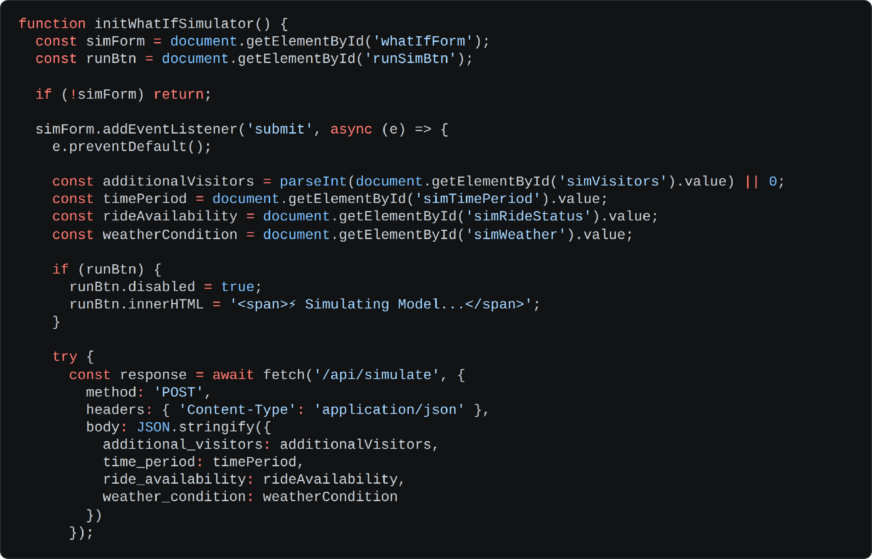
Render the Simulation Result:
- The response updates the situation summary, the recommendation text and the AI engine badge in place; a failure surfaces an alert, and the finally block always restores the button so the interface never stalls in a loading state.
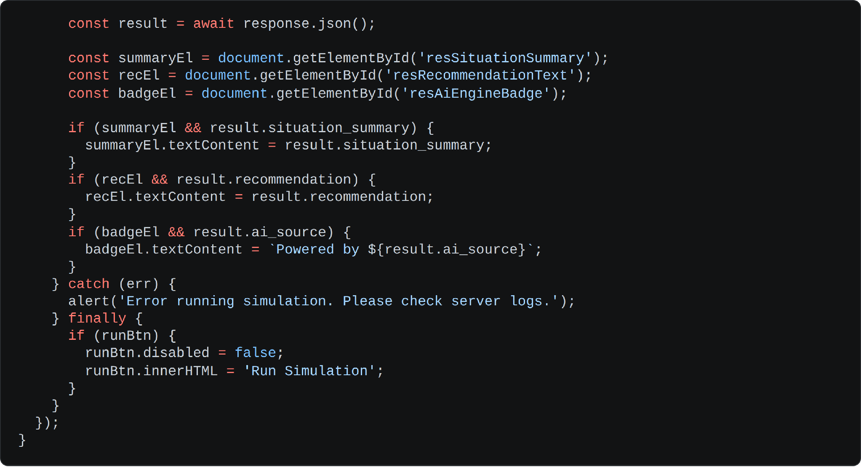
Support the Authentication Forms:
- A password visibility toggle swaps the input type and the eye icon on both the sign-in and sign-up forms, and a forgot-password modal posts to the server and reports its result inline.
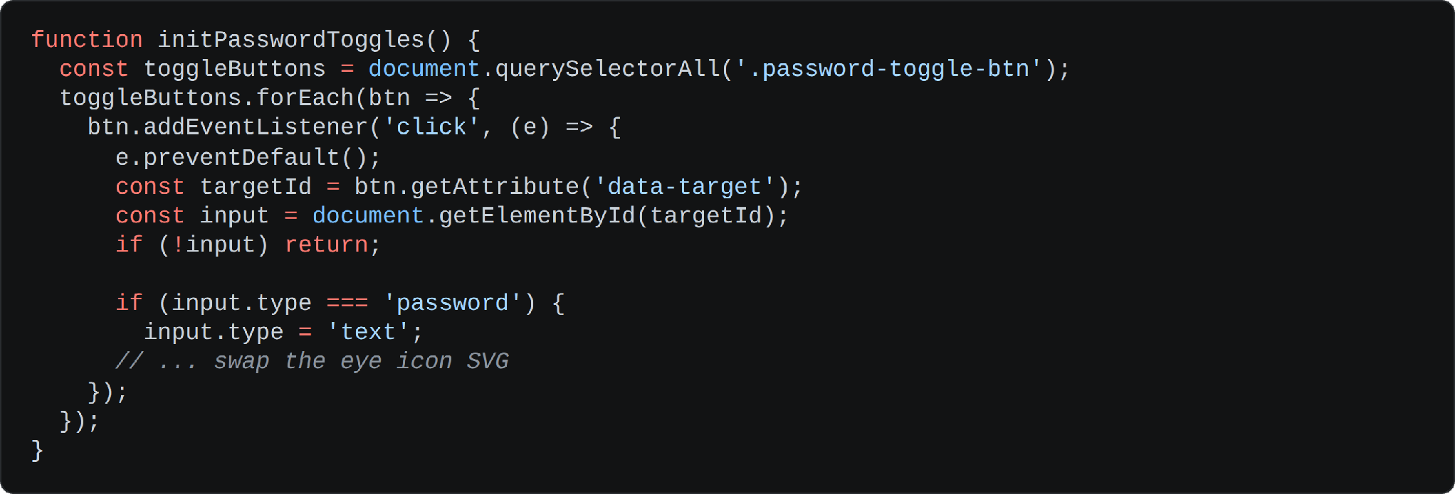

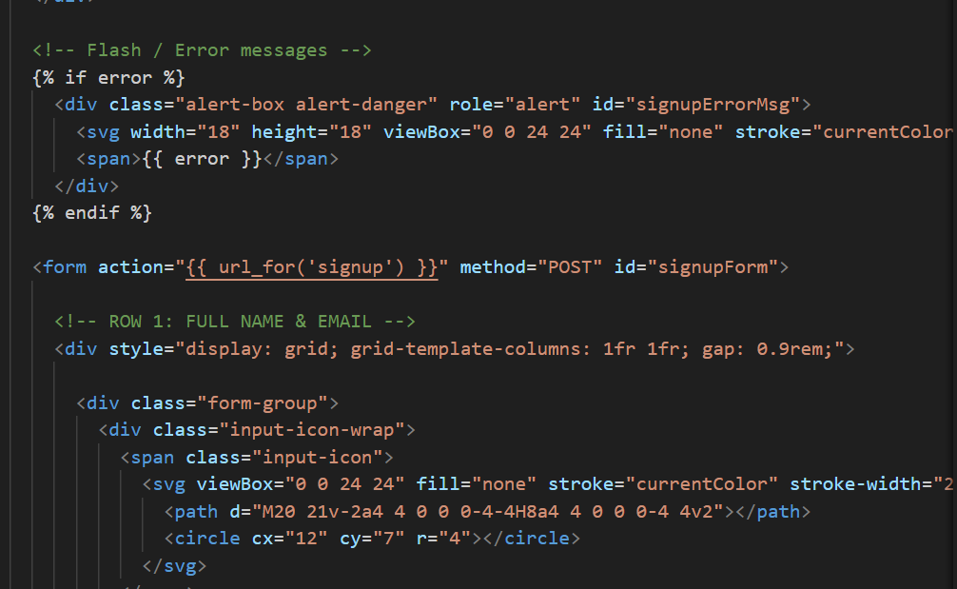
Milestone 5: Deployment
In Milestone 5 the focus is on deploying ParkOps — first locally to verify correct operation across all nine workflow stages, and then publicly via Ngrok so the application can be demonstrated over a secure, accessible URL. This involves configuring the environment, initialising the database and launching the app for real-world use.

Activity 5.1: Preparing the Application for Local Deployment
Set Up a Virtual Environment:
- Create and activate a virtual environment, then install all required dependencies from requirements.txt:
python -m venv env
source env/bin/activate # For macOS/Linux
env\Scripts\activate # For Windows
pip install -r requirements.txt
Configure Environment Variables:
- Create the .env file in the project root and add the Gemini API key and the Flask secret key. The application loads these automatically using python-dotenv at startup.
Initialise the Database:
- On first run, init_db() creates the full schema in database.db. No demo data is seeded automatically — load the demo park from the Park Data page or import your own dataset.
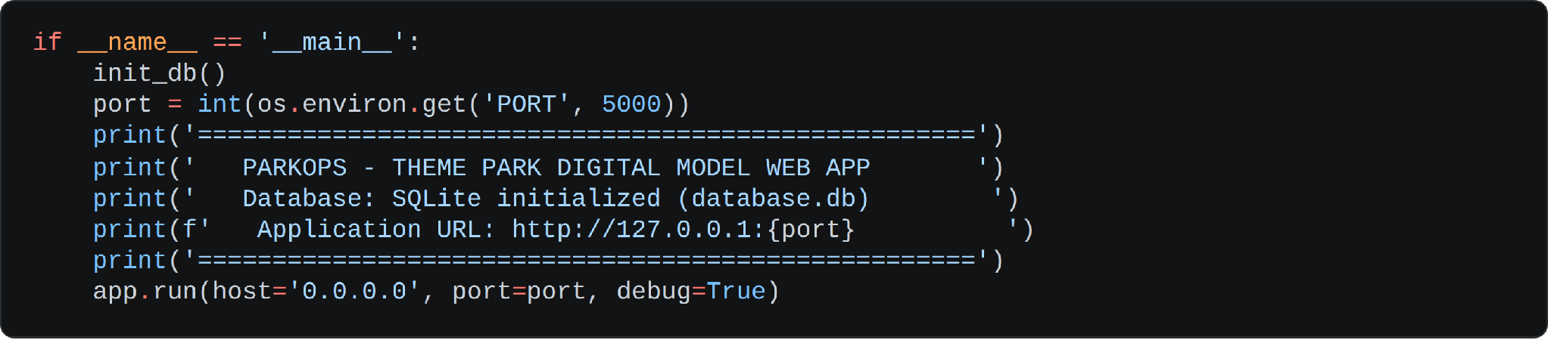

Activity 5.2: Local Testing and Verification
Start the Flask Development Server:
- Run the application locally using:
python app.py
- Once running, open a browser and navigate to http://127.0.0.1:5000 to access the application.
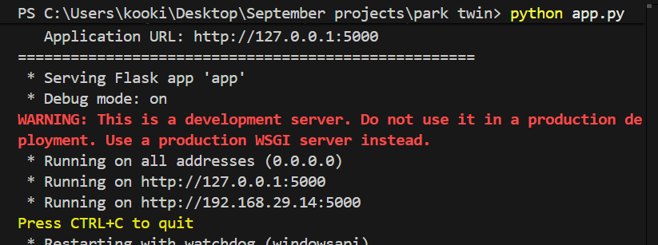
Verify Every Workflow Stage:
- Authentication: create an operator account, sign out and sign back in, confirming that a protected stage redirects an anonymous visitor to the sign-in page.
- Dataset Import: download the Excel template, upload a completed dataset, and confirm that zones, rides and facilities populate across the explorer pages.
- Monitoring and Prediction: confirm the KPI cards and charts reflect the imported dataset and that the predicted bottlenecks correspond to the highest-occupancy zones.
- What-If Simulation: run scenarios with a visitor surge, a ride breakdown and a weather change, and confirm the queue projection and bottleneck shift accordingly.
- Recommendation Engine: verify the engine badge reads “Gemini AI Connected” with a key configured, then remove the key and confirm the local fallback still returns a sensible recommendation.
- Operator Decisions and Reports: apply, save and reject a decision, then confirm each action and every simulation appear in the reports view and in the exported CSV.

Activity 5.3: Public Deployment via Ngrok
Ngrok creates a secure tunnel from a public URL to your local Flask server, making Smart CrossWalk accessible from anywhere without a cloud hosting provider. server.py already runs with debug=False and use_reloader=False, so it is already safe to pair with an Ngrok tunnel
Install Ngrok and pyngrok:
Install the pyngrok Python wrapper, which manages Ngrok programmatically within your Python project:
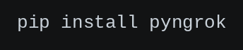
- Download and install the Ngrok client from https://ngrok.com/download.
- Click on “Microsoft Store Installer”.
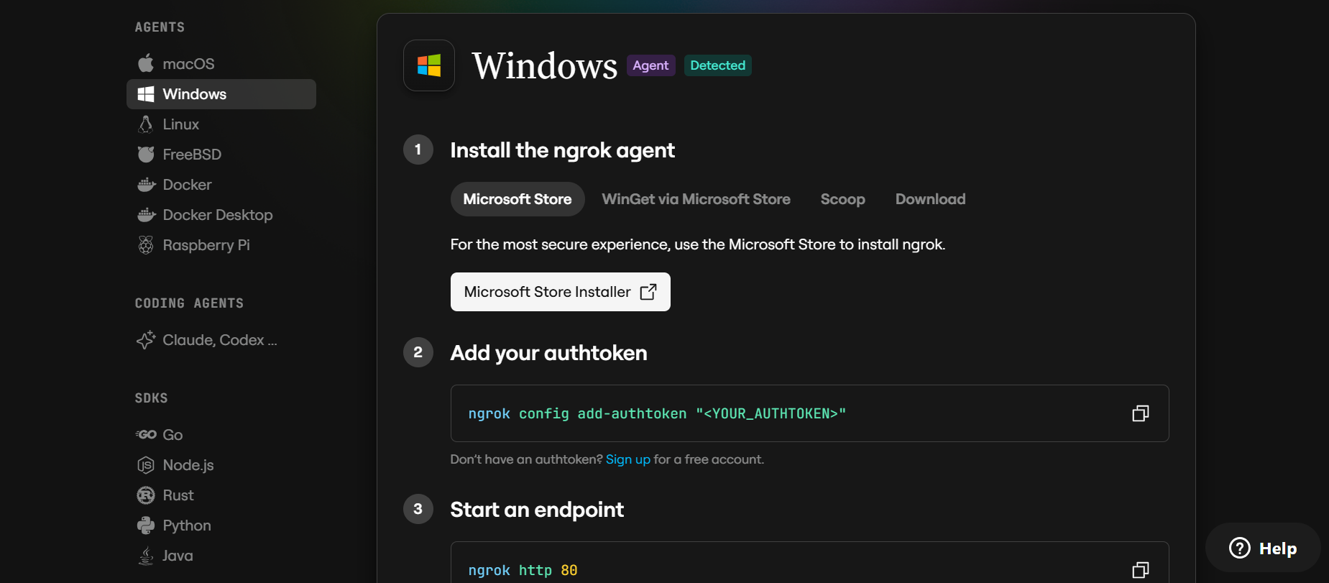

Configure Your Ngrok Authtoken:
Sign up at ngrok.com and copy your authtoken from the Ngrok dashboard.
Create a Public Deployment Script: Add a new file, run_public.py, at the project root with the following code:

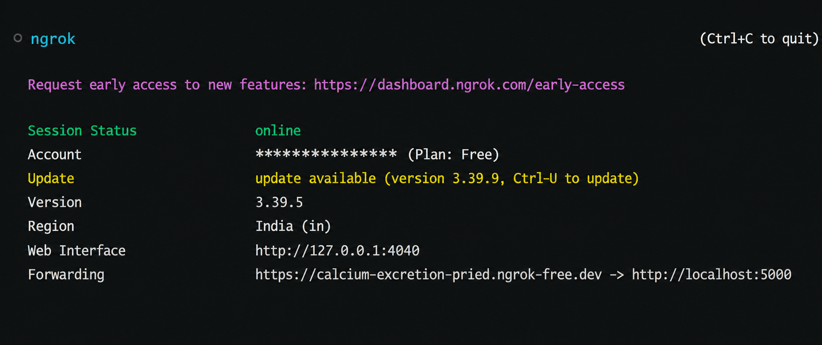
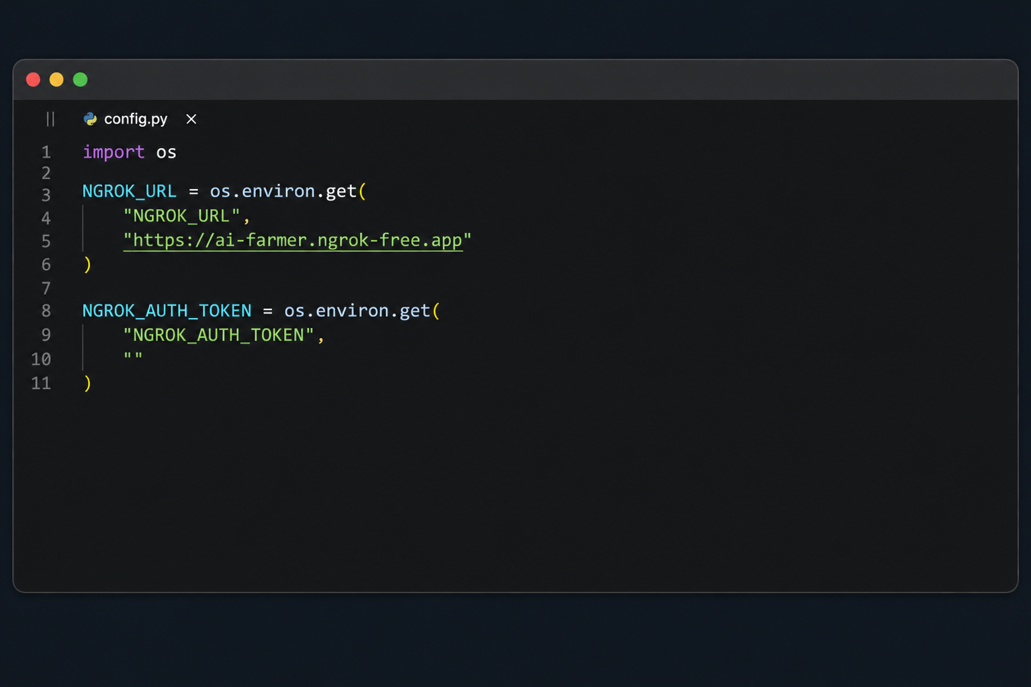
Replace YOUR_NGROK_AUTHTOKEN with your own Ngrok authtoken, or add it to .env as NGROK_AUTHTOKEN=your_ngrok_authtoken_here so it loads automatically.
Share this URL with anyone who needs to access AuraEmail directly from their browser without any local installation.
Important Notes: the public URL changes each time you restart run_public.py on the free Ngrok plan — for a persistent URL, upgrade to a paid plan and configure a reserved domain. Free-tier Ngrok sessions also expire after a few hours of inactivity; simply restart run_public.py to get a new URL when this happens.

Exploring the Website’s Web Pages:

Landing Page:
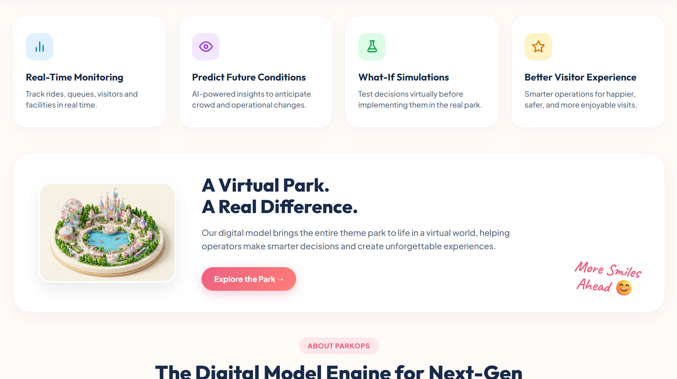
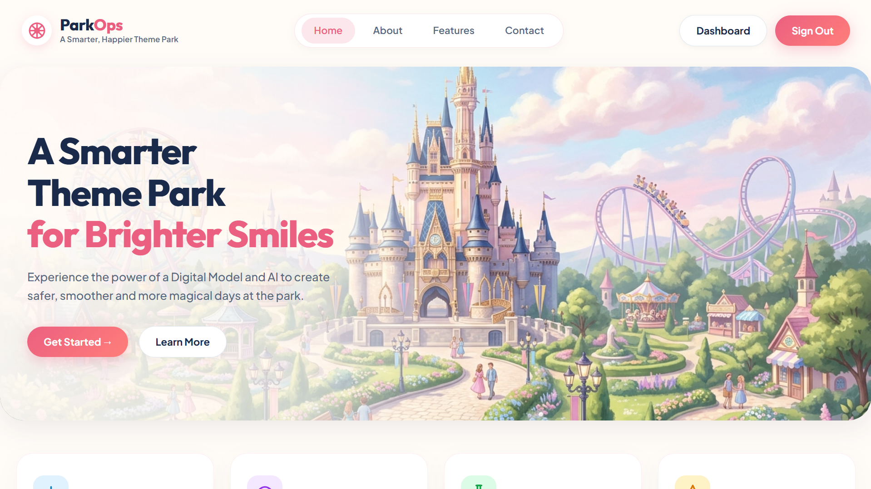
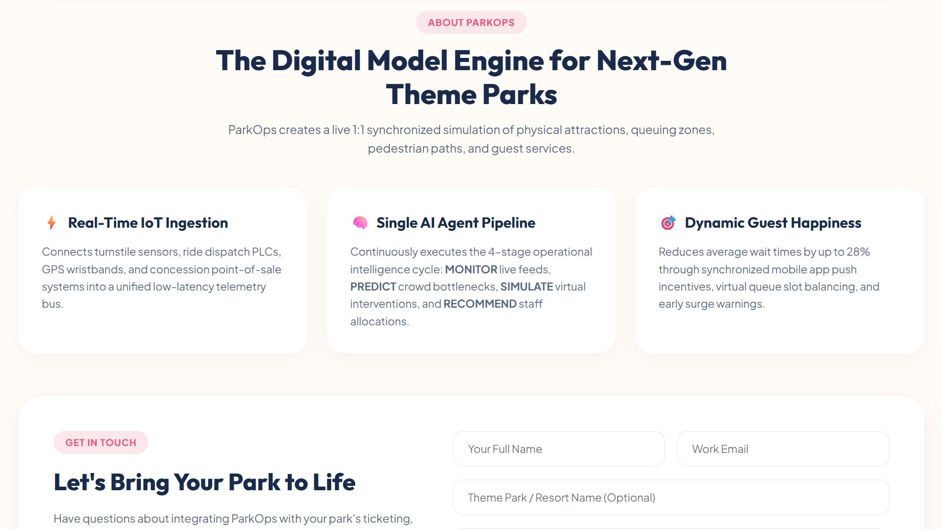
Description: The public landing page introduces ParkOps with a hero section and four capability cards — real-time monitoring, predicting future conditions, what-if simulations and a better visitor experience. A digital model section explains how the virtual replica mirrors the physical park, and a contact form at the foot of the page writes enquiries into the contacts table. The page is browsable before sign-in so a visitor can understand the platform before creating an account.

Sign Up Page:

Description: The registration form collects a full name, email address, password and confirmation, along with optional phone, country and operational role. Validation runs on both sides — the browser gives immediate feedback and the Flask handler independently enforces the required fields, the minimum password length, the password match and the email format. A duplicate email is rejected, and on success the password is hashed, the session is established and the operator is taken straight to the dashboard.

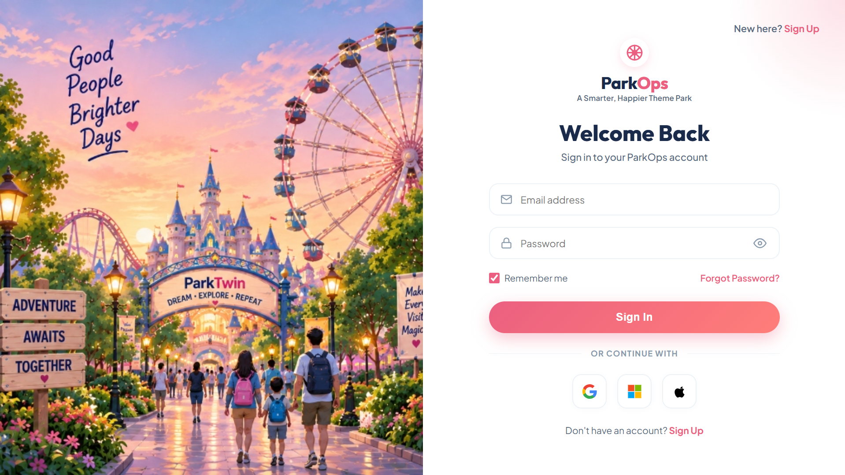
Sign In Page:

Description: The sign-in page authenticates an existing operator against the hashed credential stored in the users table, with a remember-me option and a password visibility toggle. A forgot-password modal posts to the server and reports its outcome inline. When a protected stage was requested first, the original destination is preserved so the operator lands where they intended after signing in.

Operations Dashboard:
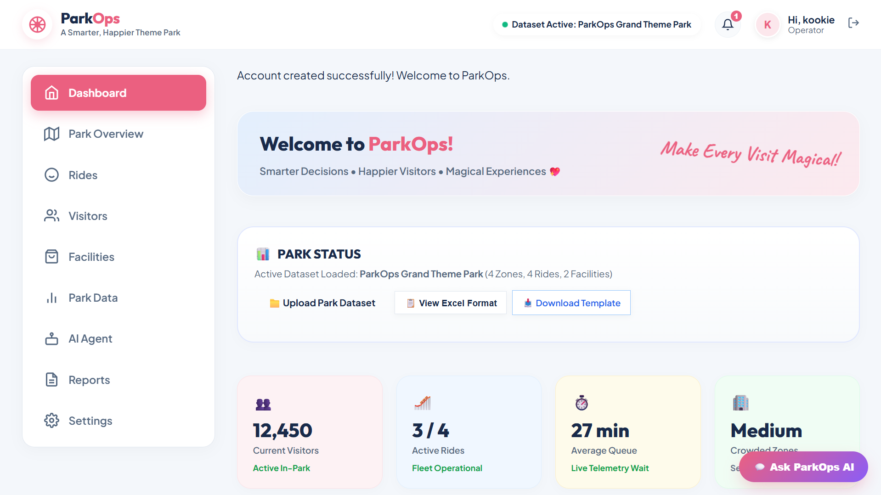
Description: The dashboard is the operator’s home view. Four KPI cards show total visitors, active rides against the fleet size, the average queue in minutes and the current crowd density band. Beneath them, chart panels plot visitor flow with an actual-versus-predicted overlay, the queue trend across the operating day, crowd distribution by zone and ride utilisation. A monitoring panel reports the agent mode, its confidence score and whether Gemini or the local engine is active.

Stage 1 — Real Park:
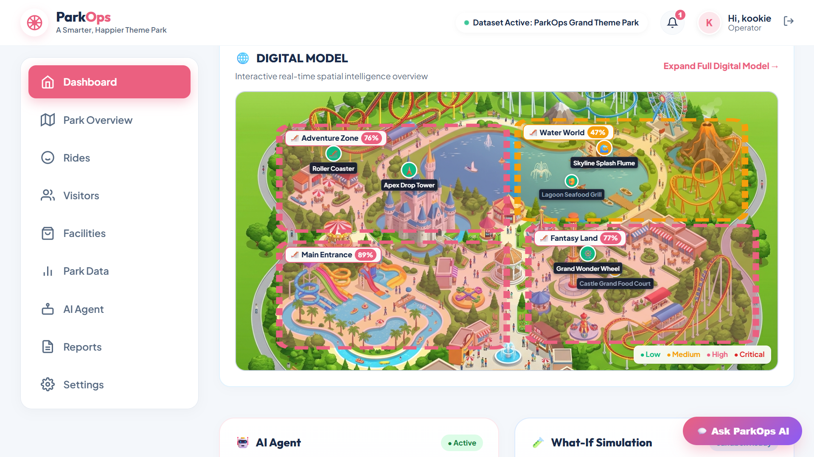
Description: The first workflow stage presents the physical park as the system currently understands it — the park metadata, operating context, weather and the live counts flowing in from turnstiles, rides and facilities. This is the ground truth that everything downstream is derived from, and the workflow header marks it as the active stage.

Stage 2 — Park Data:
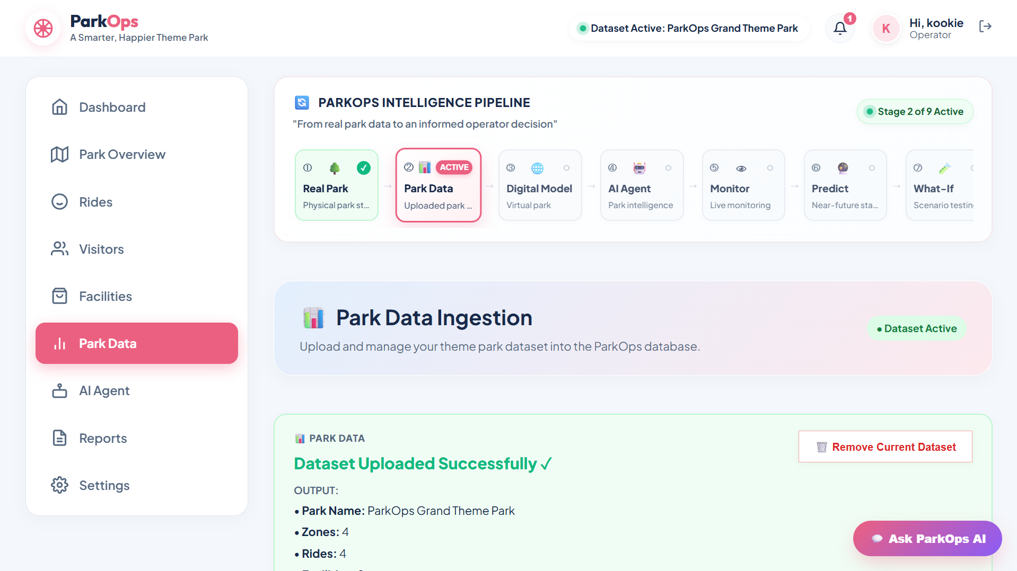
Description: The park data stage is where a real dataset enters the system. Operators can download a pre-formatted Excel template, upload a completed .xlsx, .csv or .json file, and watch the streaming import pipeline report each step as zones, rides, facilities and visitor records are written. The page also offers a demo dataset reset and a full dataset removal, so the model can be cleared and reloaded during testing.

Stage 3 — Digital Model:
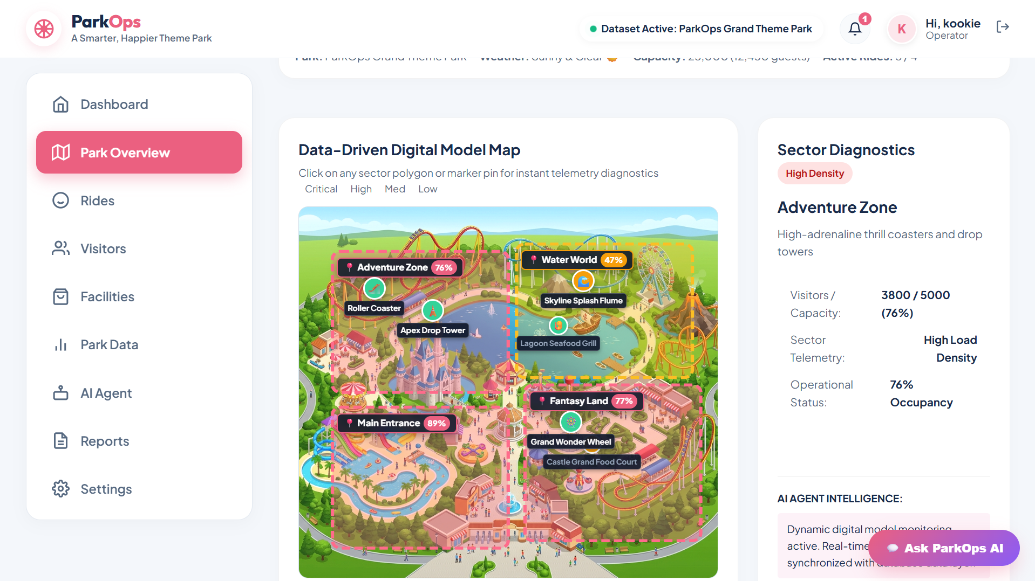
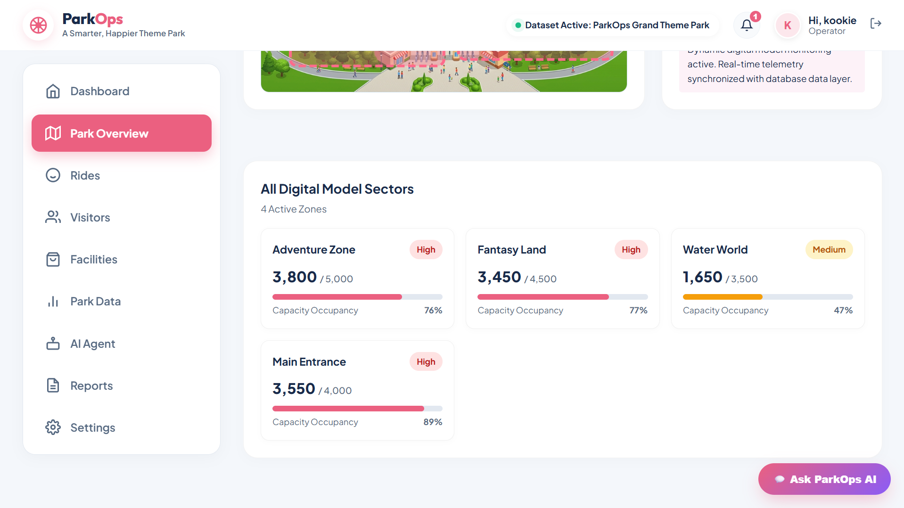
Description: The digital model stage visualises the virtual replica of the park built from the imported dataset — zone occupancy, ride status and queue lengths, facility load and the derived averages. It also makes the key architectural guarantee visible: this virtual state is what simulations operate on, which is why a what-if test can never alter the real park record.

Stage 4 — AI Agent:
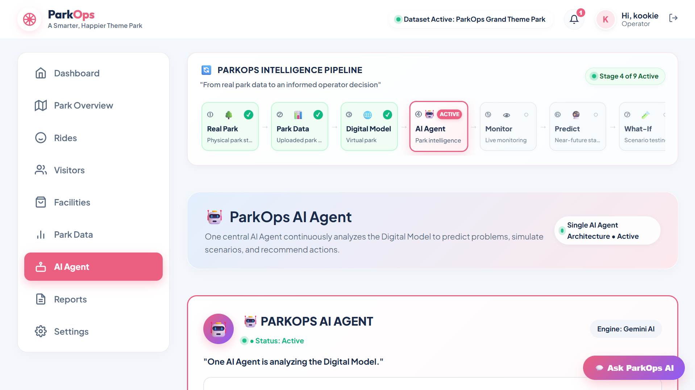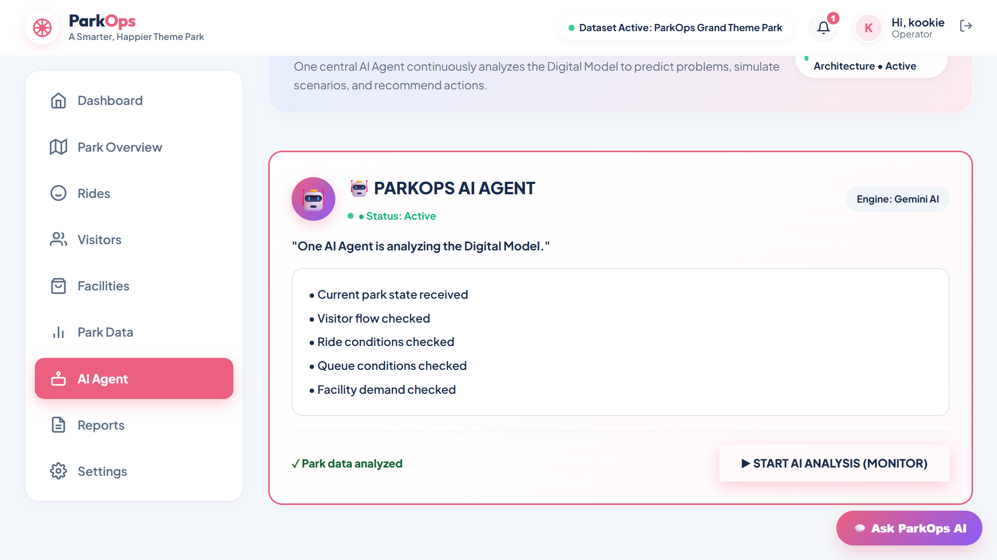
Description: The agent stage introduces the single central ParkOps Intelligence Agent and its five capabilities. A live activity timeline lists concise operational events — visitor data received, crowd density analyzed, queue trend detected, bottleneck detected, recommendation generated — each with a status colour, and a status badge reports whether the agent is running on Gemini or the local fallback engine.

Stage 5 — Monitor:
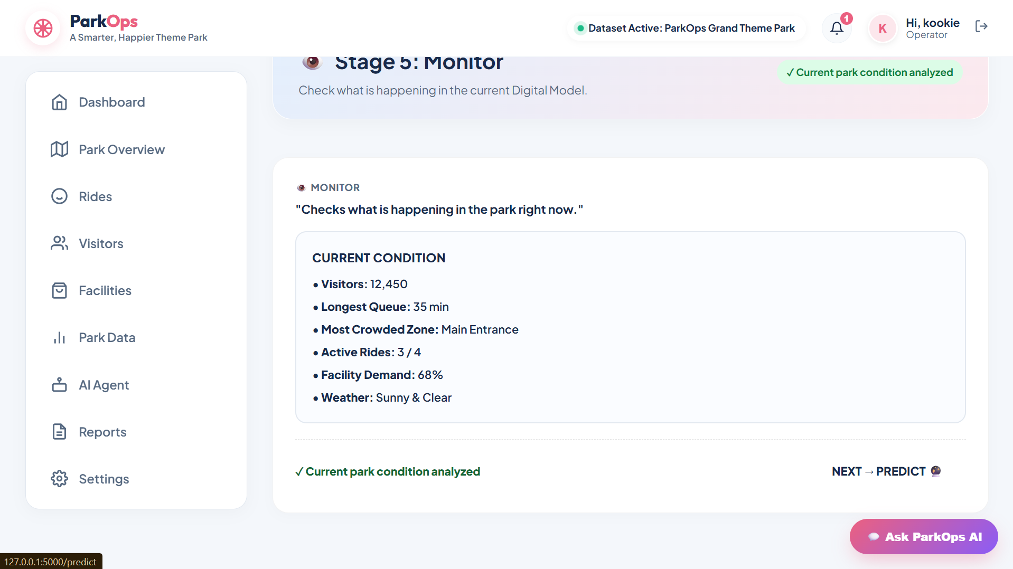
Description: The monitoring stage shows what the agent observes right now: the current headcount, active ride ratio, average queue, facility load, turnstile arrival rate and the zones currently in high density. Detected operational events are surfaced alongside the telemetry so an emerging problem is visible before it becomes a queue.

Stage 6 — Predict:
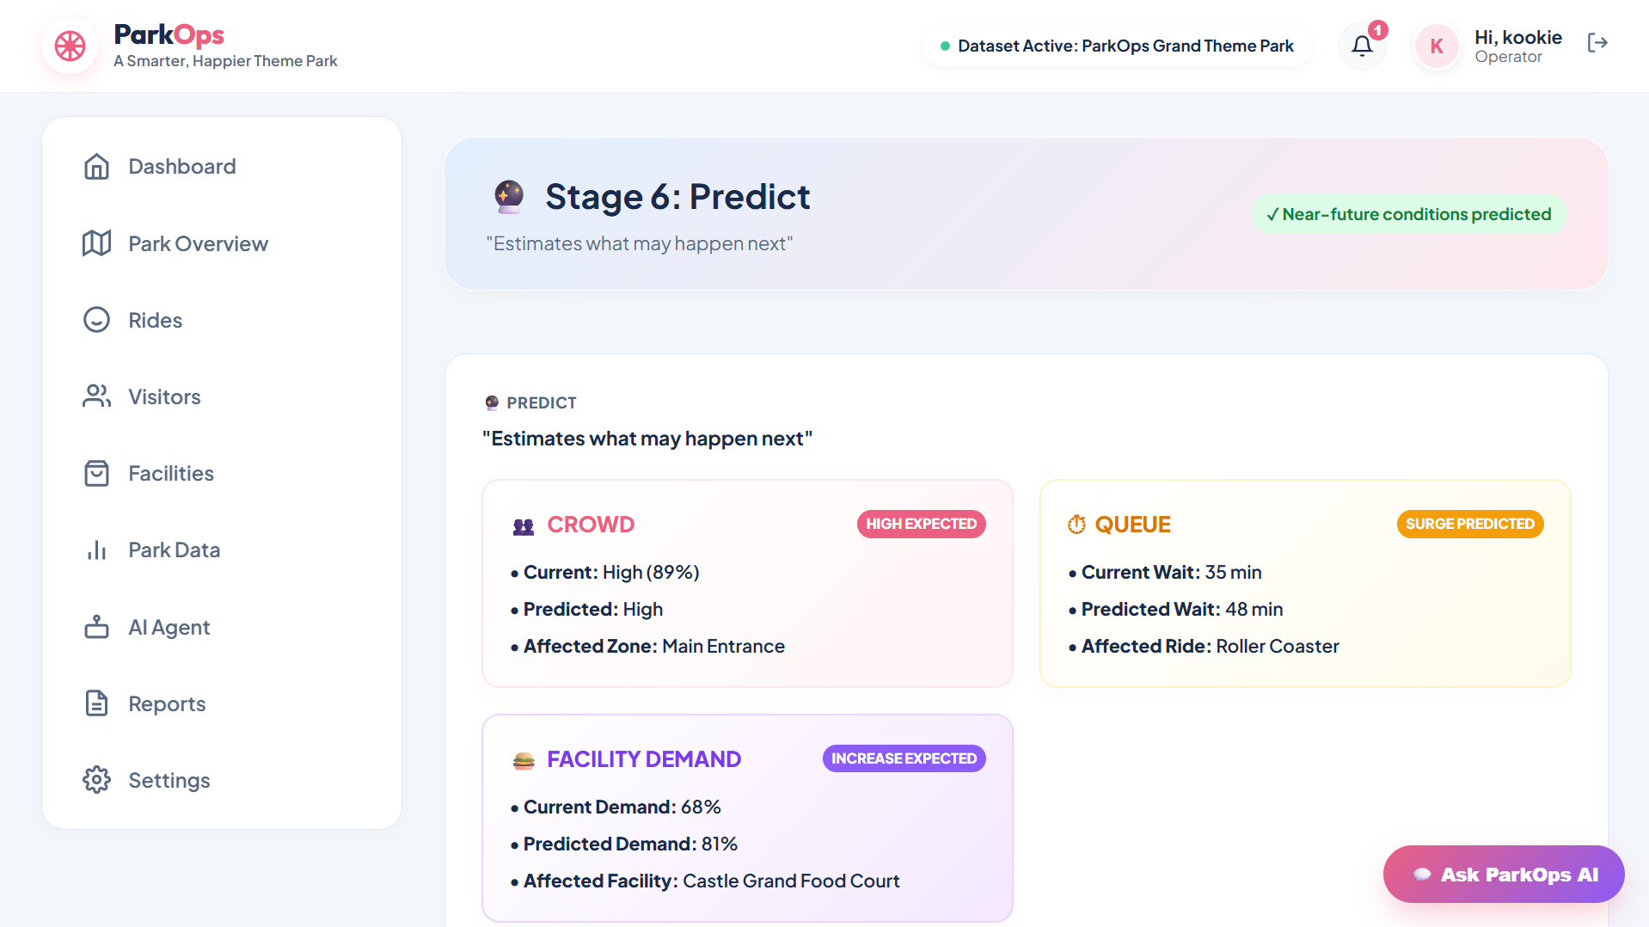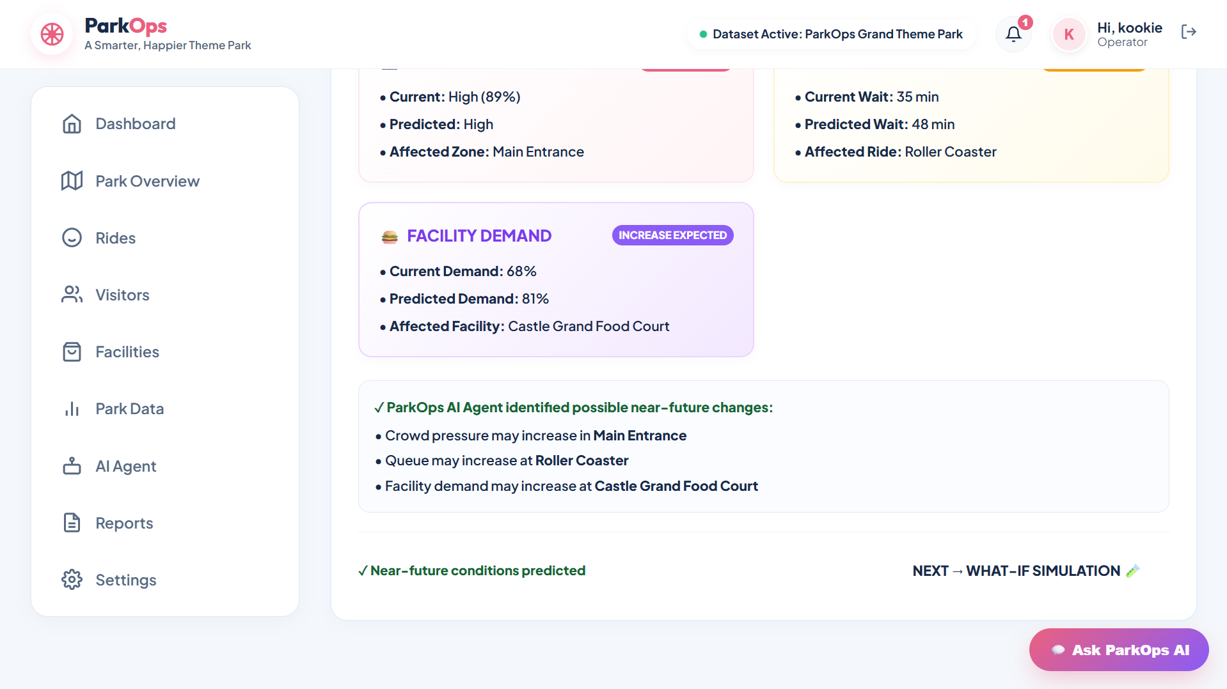
Description: The prediction stage projects the park forward over a two-hour horizon. It reports the projected visitor count, the predicted average queue and a ranked list of up to three bottleneck zones, each graded Moderate, High or Critical with an estimated queue impact in minutes, together with an overall risk assessment and the agent’s confidence.

Stage 7 — What-If Simulation:
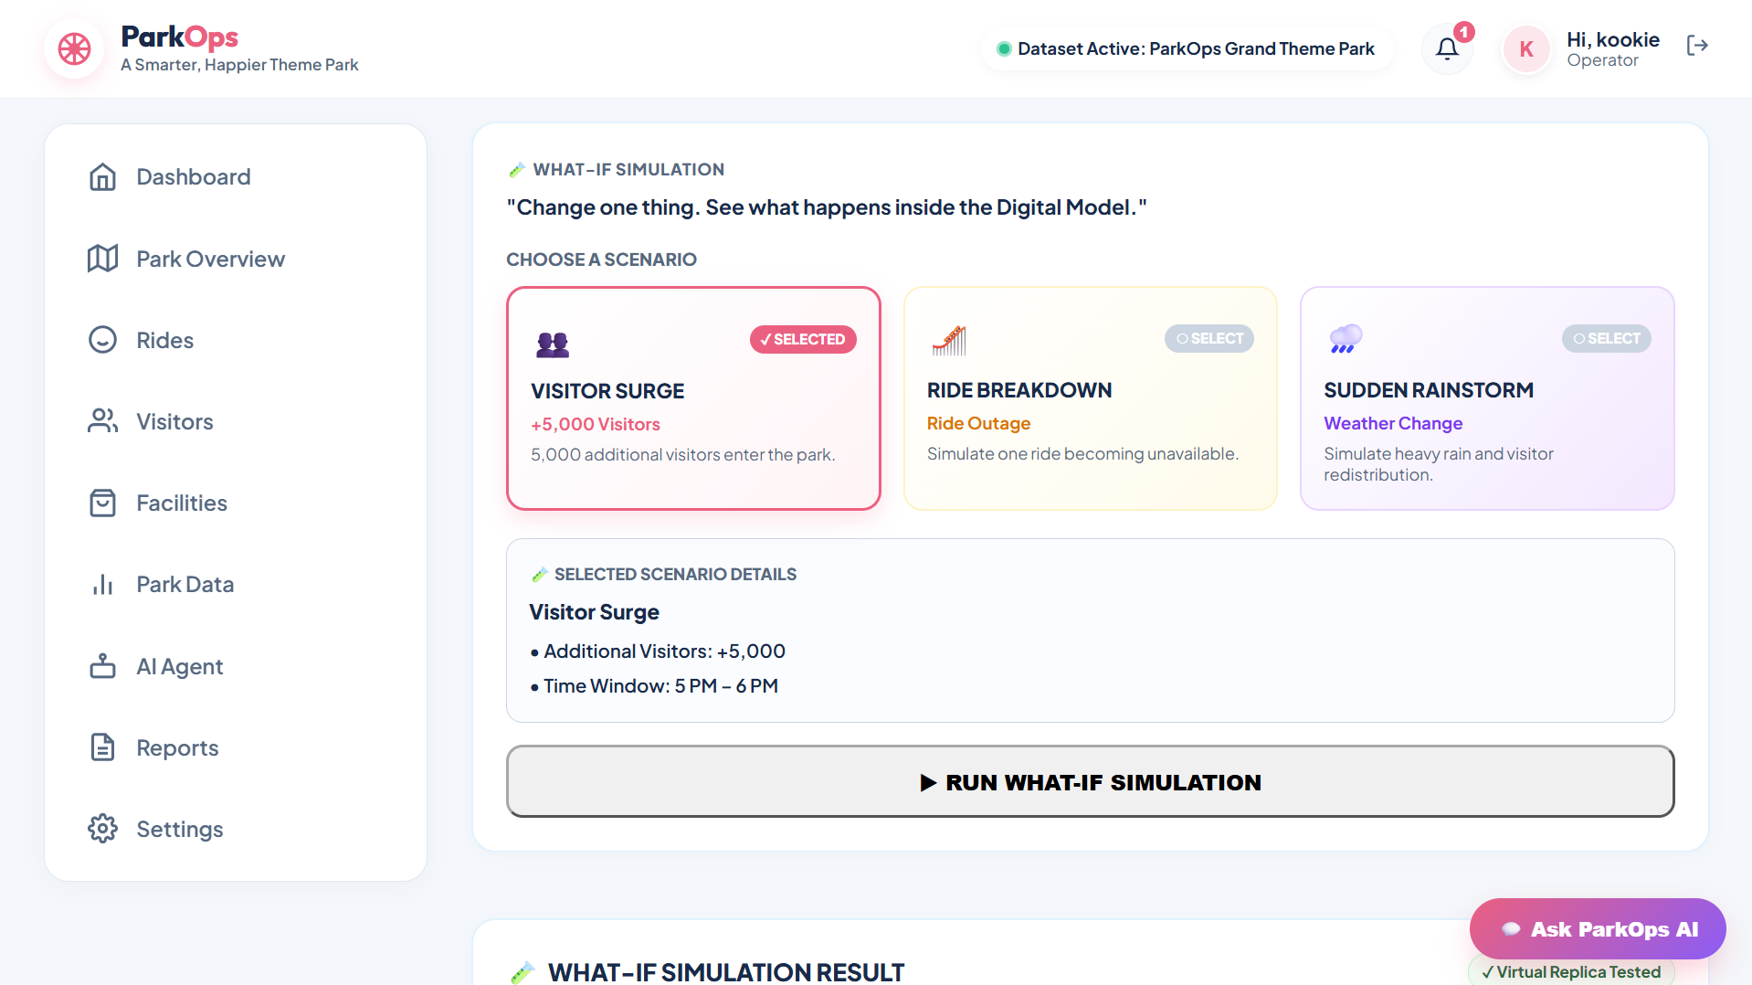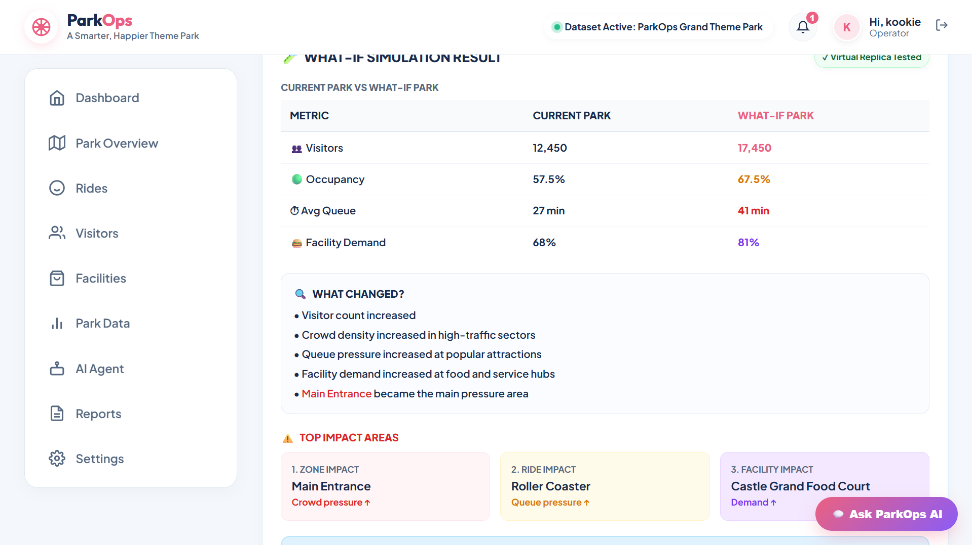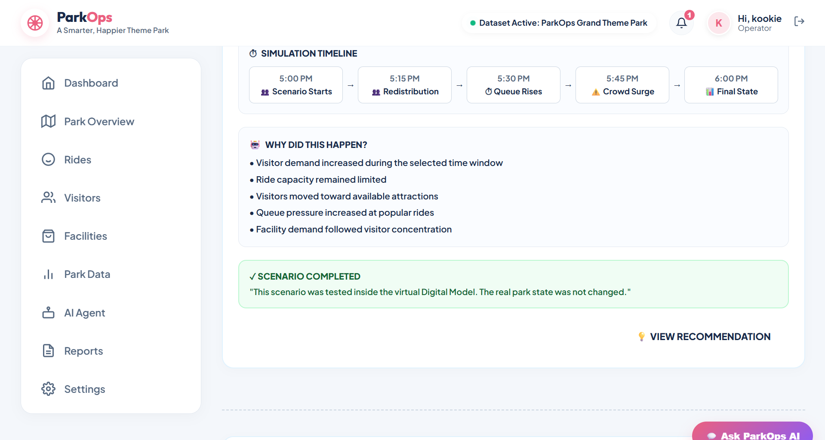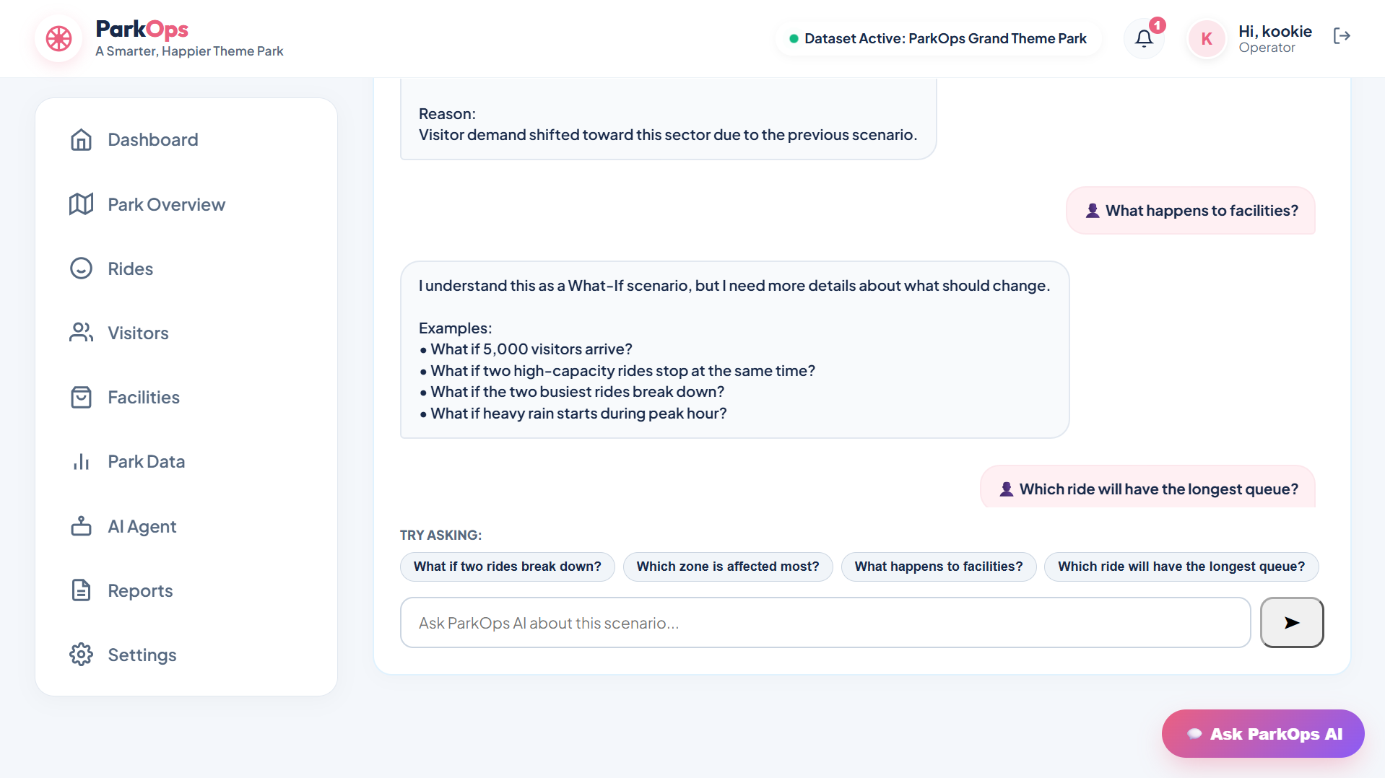
Description: The simulation stage is the sandbox. The operator enters additional visitors, the time window, the ride fleet state and the weather condition, then runs the scenario. The result returns the total predicted visitors, the predicted queue time, the crowd density band, the named bottleneck, the facility demand and a risk level — and every run is written to the simulation history for later review.

Stage 8 — Recommend:
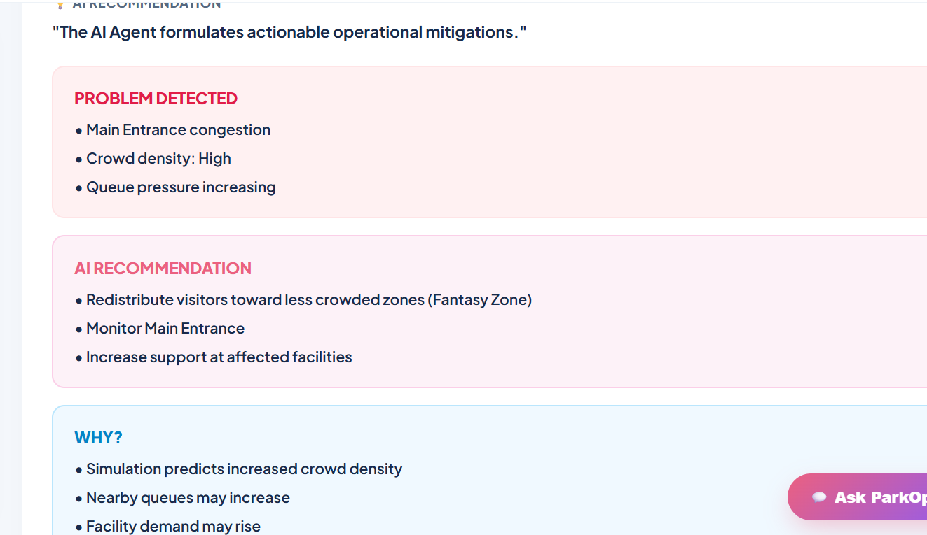
Description: The recommendation stage converts the simulation outcome into an operator instruction. The situation summary restates what the model predicts, the recommendation gives a concrete mitigation covering visitor redistribution and facility staffing, and an engine badge names whether Gemini or the local intelligence engine produced the text so the operator can weigh it appropriately.

Stage 9 — Operator Decision:
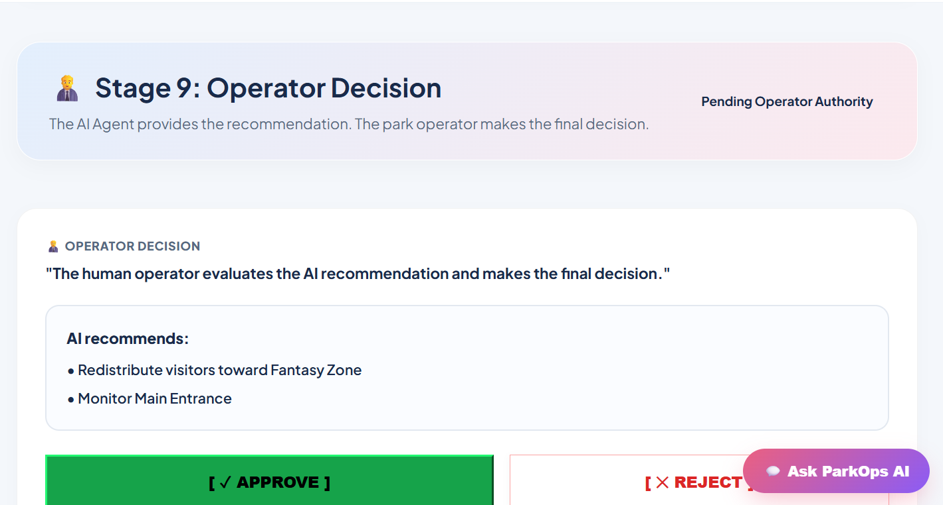
Description: The final stage keeps the human in control. The pending decision is presented with its situation, impact, prediction, risk level and confidence score, and the operator can apply, save or reject it. Whichever action is taken is persisted to the operator_decisions table with the acting operator and a timestamp, and an applied action feeds back into the digital model as an active mitigation.

What-If AI Assistant:
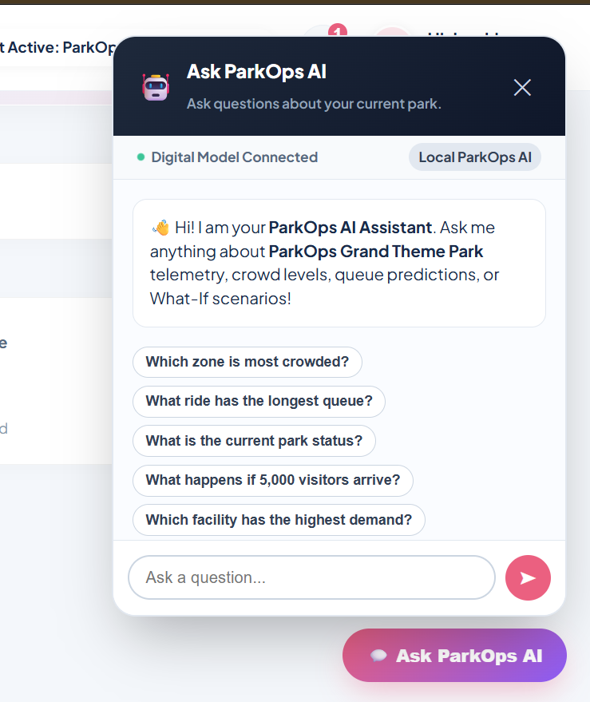
Description: The assistant answers natural-language operator questions directly against the live database state. Asking which zone is busiest, which ride has the longest queue or what would happen if a named attraction went offline returns a short, dataset-driven answer rather than a generic park summary, and a question outside park operations is politely declined and redirected.

Reports Page:
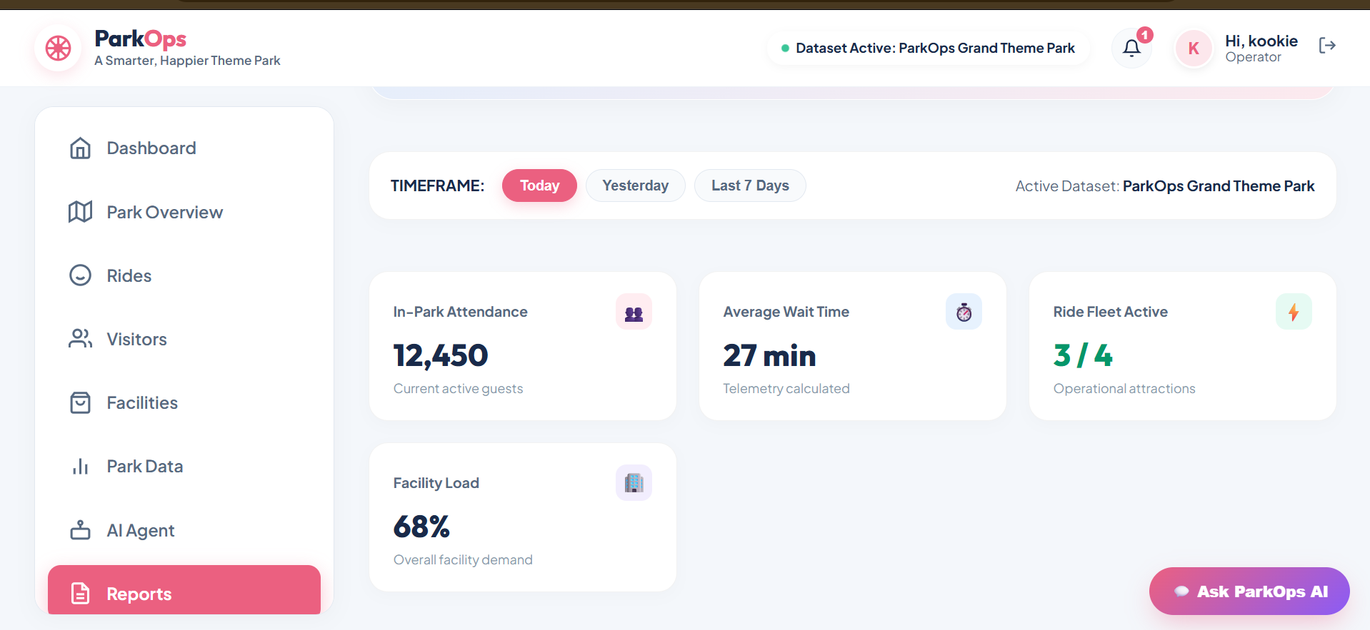
Description: The reports view lists the complete simulation history with the scenario name, the additional visitors, the time period, the weather, the predicted queue time, the crowd density, the bottleneck zone and the run timestamp. A single action exports the whole history as a CSV operational report for end-of-day review or handover.

Settings Page:
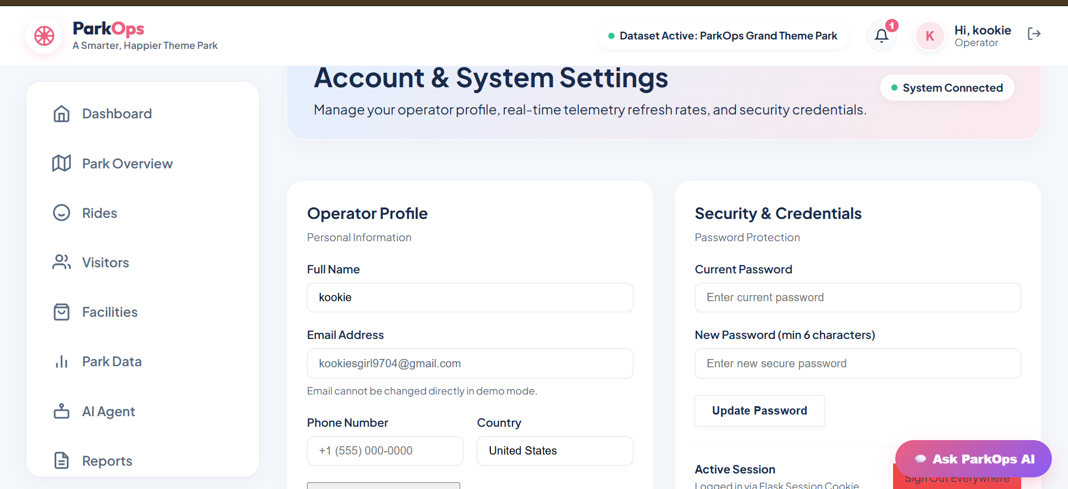
Description: Settings groups account and operational preferences into a single page, where the operator profile, contact details and role can be updated and the working preferences adjusted. Changes are submitted to the settings route, validated server-side and confirmed through a flash message on return.

Conclusion:
ParkOps is a generative AI platform built with Flask and SQLite that gives theme park operators a working digital model of their park. By routing the operational state through a single central agent with five capabilities — monitor, predict, simulate, recommend and analyze — the application turns raw telemetry into a specific, actionable instruction: which zone will congest, by how much, and what to do about it. Because every simulation runs on a virtual copy of the state, an operator can stress-test a busy evening, a ride breakdown or a weather change without any risk to the live park.
The project — spanning model selection, schema design, the digital model engine, agent development, frontend work and deployment via Ngrok — demonstrates how a carefully scoped prompt layer over a well-structured state model can make a small application behave like an experienced operations analyst. Because the Gemini path is backed by a deterministic local engine, the agent degrades gracefully instead of failing, and because every simulation and decision is persisted, the system builds an auditable record of what was predicted and what was actually done. Natural extensions include live IoT sensor ingestion, multi-park comparison, automated staffing rosters driven by predicted demand, and richer scenario comparison across parallel mitigation options.
Building upon the foundation laid in earlier milestones, Milestone 5 focuses on local deployment and verification to ensure that every layer of the system functions seamlessly before broader access is granted. The deployment process begins with initializing the SQLite database schema via init_db(), ensuring that all required tables for users, parks, rides, facilities, and simulation histories are created without forcing pre-seeded data, thereby giving operators complete control over their initial dataset. Operators then execute local verification by starting the Flask server on localhost and systematically testing each of the nine workflow stages — from user authentication and dataset import to running what-if simulations, reviewing agent recommendations, and recording final operator decisions in the audit log.
During local testing, particular attention is given to the agent's dual-engine design, confirming that the interface correctly reflects whether Gemini AI is connected or if the local deterministic engine has taken over as a fallback. Every simulation run and decision outcome is verified for consistency across the live dashboard, data explorer views, and exportable CSV operational reports. This rigorous stage-by-stage validation guarantees that the digital model accurately mirrors park telemetry, maintains isolated sandbox states during what-if testing, and preserves data integrity across all operational actions.

